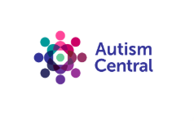
Group learning for families of autistic people
Search this link Group learning for families of autistic people | Autism Central for online events for families of autistic people to learn, reflect and work together, sharing knowledge and skills, including, education family guide sessions, reflective sessions, in conversation and masterclasses.
All events are free, NHS funded, sessions delivered by Anna Freud and are peer-led and co-produced, grounded in lived experience and research.

