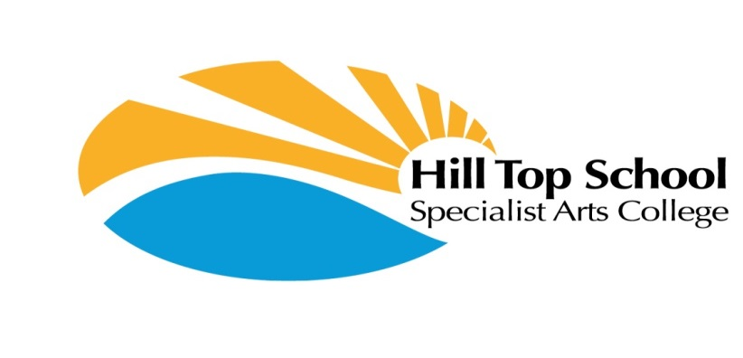
Wealcroft
Leam Lane
Gateshead
NE10 8LT
Tel: 0191 4692462
hilltopschool@gateshead.gov.uk

Head Teacher: Ms Anita Bell

20.3.25

Dear Parent / Carer

Concessionary bus pass:

If your child is under 16 and receives Disability Living Allowance (DLA) they are eligible for a free concessionary bus pass. The pass can be used all day every day.

You will need:
Copy of the front page of the DLA letter
Proof of parents address within the last 6 month (utility bill, council tax bill)
A passport style photo of the child
A completed application form (which will be sent out by the travel trainers)

If you would like your child to have a bus pass, please contact the travel trainers at Gateshead Council and they will arrange this for you. Contact either:

Jocelynarnell@gateshead.gov.uk
07849 310889

Nicolacharlton@gateshead.gov.uk
07711387842

Yours sincerely,
Anita Bell Head Teacher




