4B class blogs 2024-25
06/06/25
Class 4B have been busy rehearsing for the school performance this week and are showing their musical skills. We have JD, HM and CW on guitars; TM, DA, CH and RS bashing away on drums; and JD and AB providing keyboard accompaniment. They are doing an amazing job and we look forward to celebrating their hard work when they perform live.
The class took on a challenge this week, to build the highest tower made only of paper. We had some interesting attempts, with one group having to scrap theirs and start again. The groups worked well together and reflected on the challenge, the difficulties of team work and the skills learnt around communication as a group. The winning tower was an impressive 2.3 meters – designed and created by team ‘Nuclear Engineers’, consisting of SZ, HM and JD… and it is still currently standing!
We have also been talking about change and the upcoming transition to college, sixth form or new classes. We are working on resilience and how we feel when something new happens and we will continue this over the coming weeks to ensure students are supported as they face the exciting new challenges ahead.
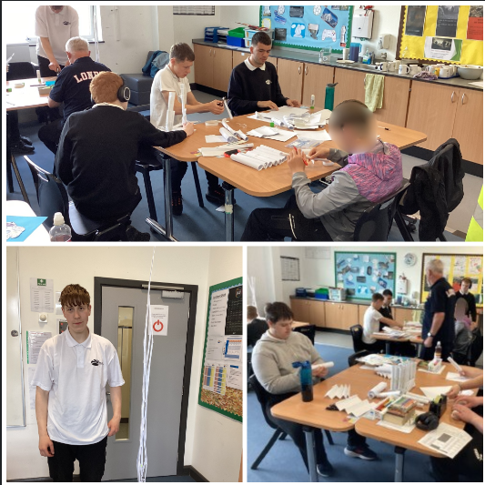
16/05/25
4B students have been completing practise assessment papers for Entry Level English this week. They approached this in a calm manner and carried out the required tasks with positivity and determination.
In preparation of the second assessment paper the class wrote emails to a fictional local councillor to suggest improvements to their local park. The work was well-written, and a lot of consideration went into what they wanted to say in the messages. Some students then worked on a response from the councillor. This work will be useful when the students need to contact departments within colleges or for employment purposes.
Maths was all about refreshing some important aspects. This included subtraction (taking away) and telling the time – which was relevant to many as they rely on digital devices rather than the traditional clocks. Tricky examples where they had to work out how much time had elapsed between two different times were attempted and they had fun using an online clock to set different hours and minutes.
In PSHE the class discussed, and watched a video on sexual identity and it was impressive to see how accepting they were of the different needs of others within society. They have been covering various other issues around body shaming and awareness of others and this tied in with those themes.
Finally, pupils have been working on growth and resilience again, developing their understanding of their own triggers and needs, while learning strategies to improve how they handle stress and anxiety. One of the main themes discussed was change around college and how leaving school is ‘tricky’. There was also a conversation about internal change and nervousness around new classes next year. The students handled all topics with maturity and asked important questions.
They are now looking forward to some upcoming events, especially the Summer Performance, where the majority of the class are the ‘house band’.
04/04/25
Class 4B have covered a range of topics this week. In maths, they produced a questionnaire for fellow students to complete, covering favourite games, devices, fast foods and many more.
In English, poetry has been the main thrust of the term and the students have really embraced the opportunity to show their creativity again. Firstly, they produced a ‘shape poem’ – a poem based on a shape of their choosing. In 4B’s case this meant poems about cars, football and missiles. Later in the week, they performed a poem, creating a rhythmic beat to accompany From a Railway Carriage Window, a piece set on a train. The students did a good job finding things to use for the rhythmic beat of a train. Finally, the class made WW1 posters, but this time with a difference. Instead of posters encouraging ward they produced anti-war versions that outlined the horror of war.
In Independent Living Skills, the class joined with 4C for a session looking at the rainforests and how humans are destroying them. They discussed the reasons behind it and the consequences of cutting down so much of the natural habitat.
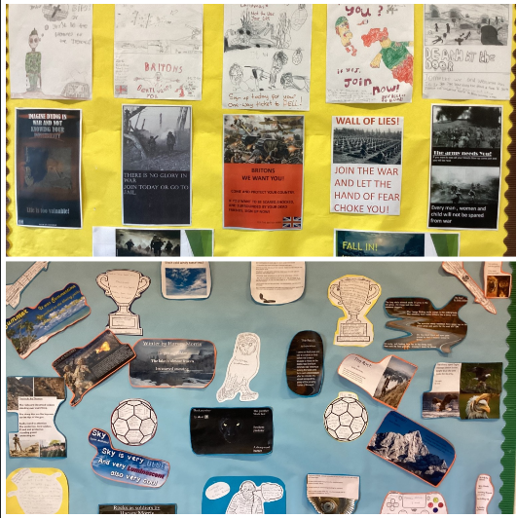

21/03/25
4B have had a busy and varied week. TM, CH and JD played in a series of football matches on Thursday in Gosforth, returning suitably shattered from their efforts. The whole class have been working on a music video in media lessons, creating a pop-like clip using Slipknot as the background. In English, they have been planning a metaphor poem, where they will be describing natural elements as animals or humans. They also created ‘The Hill Top Rap’ – based on rhyming couplets.
Yo! I’m coming to you from HT,
sometimes that is a mad place to be.
At times the kidz can get wild,
which makes the teachers feel riled.
Running, jumping and the beep test,
luckily no one had a cardiac arrest.
Creativity in lessons makes us inspired,
after all this fun, we go home tired.
On Friday, the class took a bus to Newcastle and walked across The Millennium Bridge and viewed the art in The Baltic Gallery, before walking to Trinity Square to catch a bus back to school.
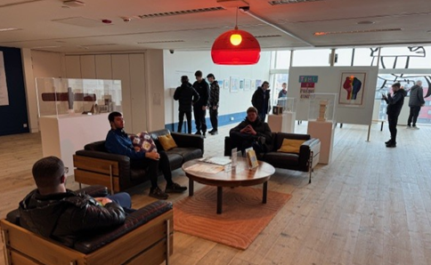
14/02/25
This week was all fun and games for 4B in Media Studies, as they filmed another section of their final Audio-Visual Sequence, where famous scientists crossed swords and danced!
In PE, pupils have played various of mini games in Boccia to improve their skills for next week’s Inter-house Boccia event. Pupils were looking to improve their accuracy.
The highlight of the week has been the trip to Newcastle Cathedral where the students spent time looking around the Norman Cathedral. One thing they were keen to see was the Baptismal Font as they have been learning about the Christian naming celebration.
The font in Newcastle Cathedral is very interesting and filled with holy water, which is used by visitors to sign themselves with the mark of the cross when entering to pray or reflect.
The biographies that students are working on are coming together, with a range of people covered. We are looking forward to finding out about the subjects which include: Bobby Charlton, David Goggins, Gabe Newall and Alan Becker.
Finally, the class have been exploring the importance of immunity and how the body fights diseases. They have completed group work and learnt about how pathogens can find ways to get into our system and attack us from the inside.
31/01/25
This week was an important week with regards to remembering The Holocaust and 4B, like the rest of the school, were taking part in the memorial to the 80th year since liberation of the concentration camp known as Auschwitz.
Last week the students joined an online talk, given by a survivor of the camp, which provided much food for thought as the reality was exposed. It led to an interesting discussion about what would happen to many of the people in our school if we were to be subjected to the same discrimination.
On Monday, the class took part in an assembly, leading to an activity where they imagined what it would be like to be crammed into one of the rail carriages as they were transported to the death camp. Students wrote down imagined thoughts and phrases that the people might think or say. They then followed this by putting the carriages on the wall, forming a long train, filled with sad thoughts and emotive feelings – it was a somber and heartfelt moment.
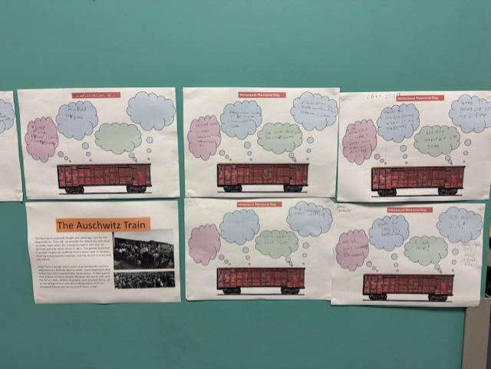
4B class Blog

Welcome to 4B's class blog. Here you will see regular updates from our class giving you an insight into the work we get up to.
06/06/25
Class 4B have been busy rehearsing for the school performance this week and are showing their musical skills. We have JD, HM and CW on guitars; TM, DA, CH and RS bashing away on drums; and JD and AB providing keyboard accompaniment. They are doing an amazing job and we look forward to celebrating their hard work when they perform live.
The class took on a challenge this week, to build the highest tower made only of paper. We had some interesting attempts, with one group having to scrap theirs and start again. The groups worked well together and reflected on the challenge, the difficulties of team work and the skills learnt around communication as a group. The winning tower was an impressive 2.3 meters – designed and created by team ‘Nuclear Engineers’, consisting of SZ, HM and JD… and it is still currently standing!
We have also been talking about change and the upcoming transition to college, sixth form or new classes. We are working on resilience and how we feel when something new happens and we will continue this over the coming weeks to ensure students are supported as they face the exciting new challenges ahead.
6th June 2025

16/05/25
4B students have been completing practise assessment papers for Entry Level English this week. They approached this in a calm manner and carried out the required tasks with positivity and determination.
In preparation of the second assessment paper the class wrote emails to a fictional local councillor to suggest improvements to their local park. The work was well-written, and a lot of consideration went into what they wanted to say in the messages. Some students then worked on a response from the councillor. This work will be useful when the students need to contact departments within colleges or for employment purposes.
Maths was all about refreshing some important aspects. This included subtraction (taking away) and telling the time – which was relevant to many as they rely on digital devices rather than the traditional clocks. Tricky examples where they had to work out how much time had elapsed between two different times were attempted and they had fun using an online clock to set different hours and minutes.
In PSHE the class discussed, and watched a video on sexual identity and it was impressive to see how accepting they were of the different needs of others within society. They have been covering various other issues around body shaming and awareness of others and this tied in with those themes.
Finally, pupils have been working on growth and resilience again, developing their understanding of their own triggers and needs, while learning strategies to improve how they handle stress and anxiety. One of the main themes discussed was change around college and how leaving school is ‘tricky’. There was also a conversation about internal change and nervousness around new classes next year. The students handled all topics with maturity and asked important questions.
They are now looking forward to some upcoming events, especially the Summer Performance, where the majority of the class are the ‘house band’.
04/04/25
Class 4B have covered a range of topics this week. In maths, they produced a questionnaire for fellow students to complete, covering favourite games, devices, fast foods and many more.
In English, poetry has been the main thrust of the term and the students have really embraced the opportunity to show their creativity again. Firstly, they produced a ‘shape poem’ – a poem based on a shape of their choosing. In 4B’s case this meant poems about cars, football and missiles. Later in the week, they performed a poem, creating a rhythmic beat to accompany From a Railway Carriage Window, a piece set on a train. The students did a good job finding things to use for the rhythmic beat of a train. Finally, the class made WW1 posters, but this time with a difference. Instead of posters encouraging ward they produced anti-war versions that outlined the horror of war.
In Independent Living Skills, the class joined with 4C for a session looking at the rainforests and how humans are destroying them. They discussed the reasons behind it and the consequences of cutting down so much of the natural habitat.
4th April 2025

21/03/25
4B have had a busy and varied week. TM, CH and JD played in a series of football matches on Thursday in Gosforth, returning suitably shattered from their efforts. The whole class have been working on a music video in media lessons, creating a pop-like clip using Slipknot as the background. In English, they have been planning a metaphor poem, where they will be describing natural elements as animals or humans. They also created ‘The Hill Top Rap’ – based on rhyming couplets.
Yo! I’m coming to you from HT,
sometimes that is a mad place to be.
At times the kidz can get wild,
which makes the teachers feel riled.
Running, jumping and the beep test,
luckily no one had a cardiac arrest.
Creativity in lessons makes us inspired,
after all this fun, we go home tired.
On Friday, the class took a bus to Newcastle and walked across The Millennium Bridge and viewed the art in The Baltic Gallery, before walking to Trinity Square to catch a bus back to school.
21st March 2025
14/02/25
This week was all fun and games for 4B in Media Studies, as they filmed another section of their final Audio-Visual Sequence, where famous scientists crossed swords and danced!
In PE, pupils have played various of mini games in Boccia to improve their skills for next week’s Inter-house Boccia event. Pupils were looking to improve their accuracy.
The highlight of the week has been the trip to Newcastle Cathedral where the students spent time looking around the Norman Cathedral. One thing they were keen to see was the Baptismal Font as they have been learning about the Christian naming celebration.
The font in Newcastle Cathedral is very interesting and filled with holy water, which is used by visitors to sign themselves with the mark of the cross when entering to pray or reflect.
The biographies that students are working on are coming together, with a range of people covered. We are looking forward to finding out about the subjects which include: Bobby Charlton, David Goggins, Gabe Newall and Alan Becker.
Finally, the class have been exploring the importance of immunity and how the body fights diseases. They have completed group work and learnt about how pathogens can find ways to get into our system and attack us from the inside.
31/01/25
This week was an important week with regards to remembering The Holocaust and 4B, like the rest of the school, were taking part in the memorial to the 80th year since liberation of the concentration camp known as Auschwitz.
Last week the students joined an online talk, given by a survivor of the camp, which provided much food for thought as the reality was exposed. It led to an interesting discussion about what would happen to many of the people in our school if we were to be subjected to the same discrimination.
On Monday, the class took part in an assembly, leading to an activity where they imagined what it would be like to be crammed into one of the rail carriages as they were transported to the death camp. Students wrote down imagined thoughts and phrases that the people might think or say. They then followed this by putting the carriages on the wall, forming a long train, filled with sad thoughts and emotive feelings – it was a somber and heartfelt moment.

17/01/24
Students in 4B have been exploring autobiographical writing this week, looking at the key features of an autobiography and the differences between that and biographies. They identified the need to write in the first person when writing about themselves, compared to writing in the third person for biographical writing.
Students spend time understanding sequencing and chronological order, to support their own writing and they created an autobiographical paragraph covering some simple information about their lives so far.
4B have also started a new topic in maths – geometry – and have been practising drawing perfect circles using pairs of compasses, which many have used for the first time. They have also been finding examples in nature of typical shapes, to see how often geometry s reflected in the environment.
Students are also busy planning the creation of their own movies after exploring camera angles and ligting
The students also walked to Wreckenton to complete more travel training, building confidence with crossings and coping in busy shop environments. They all coped well and many of them are learning to manage money and interacting with shop staff and fellow customers politely and with respect.
06/12/24

Law and Order has been a theme this week as the class have been discussing crime in Independent Living Skills. They were considering different crimes and what punishments might be given for them. They also discussed the importance of laws amongst society.

The students have also been completing papers on measurement, finishing off the recent topic in maths. The class have had fun measuring and weighing different items to see if their predictions were correct.
The class also had a visitor in the guise of The Ghost of Christmas Past. They are learning about Scrooge and life in Victorian times and this week they focused on the experience of Scrooge as he was shown memories from his past. The students were interested to understand the emotions of Scrooge and the effect that seeing himself as a young man had on him.
In other news, half of the class, TM, DA, SZ, RS and CH represented the school at a basketball event, where they played eight games and performed really well. They came back exhausted but buzzing from the experience.
29/11/24
This week, the class have been working hard across all subjects. It has been a calm and considerate environment and particularly supportive of a pupil going through some specific challenges.
In English they have been pleased with the work on characters from A Christmas Carol and they have been brushing up on their evidence gathering skills, to explore how characters are portrayed through descriptive language. They have also been discussing the effects on alcohol and smoking in science, leading to some creative posters outlining the dangers of obesity. Animal Rights and the impact on the environment was also a big theme this week as students learnt about the consequences caused by large scale animal farming.
The class have been out and about too. Last Friday they spent the morning in Newcastle, visiting the market and an Asian Supermarket, where they purchased a range of interesting foods to try. This week they stayed local and visited the nearby shop and then made hot chocolate, ready for the class discussion about living in the community.
Overall, it has been a productive week, with students demonstrating enthusiasm, positivity and empathy

