3D Class blogs 2024-25
30/06/25
Monday : Over the last few weeks in P.E we have been preparing for the school sports day on Friday 4th July. In maths we are still practicing addition, subtraction and multiplication.Humanities consisted of climate change simulations. How many years it takes for a school to submerge.
Tuesday: Roald Dalh has been the topic for this half term. We learnt a lot about Roald Dalh's life and created a fact file. This week in Drama 3D have been doing some phenomenal work with monologue: taking a line from written monologue and adding their personal improvisation into it to make it uniquely theirs. They are working towards performing with conviction and focus next week for their finale for the year. Superb work 3D.
Wednesday: Science is a continuation on renewable and non renewable sources. Art is finishing off portraits.
Thursday: PSHE we have looked at xenophobia, racism and extreme nationalism, why are they so dangerous in Britain.
Friday : Sports day has arrived "good luck everyone
23/05/25
Maths - we are looking at digit column calculations with or without exchanging.
P.E - on Wednesday 21st there was an inter house cricket event in school. Yellow team won
R.E - we took part in the Holocaust 365 Project. This involved virtual reality head sets. We learnt about a holocaust survivor called Manfred Goldberg his brother Herman and his mum and dad. We joined them on their journey to a concentration camp during World War 2. Thank you, Mrs Whitehead for giving us this opportunity.
Food Tech - a continuation of using the air fryers. We cooked tater tots, burger, pitta bread, salad and spices

09/05/25
This was a short week due to Bank Holiday Monday.
English - was a continuation of poetry - poetree. We did shape poems 3D decided on a tree
Maths - number bonds within 100
Drama - 3D have been honing their skills on their chosen instruments and playing together like a real band.
P.E - tennis is the theme for this half term
Science - some excellent progress has been made in investigating living things and their habitat.
Food Tech - we made pizza wraps successfully in the air fryer.
P.S.H.E - work skills and the working environment .
We finished the week off with an imuse session followed by swimming and PLL not forgetting the book Fayre.

04/04/25
Monday is here again so we eased ourselves into P.E still focusing on our individual gymnastics routine. Then in humanities we watched a video on The Great fire of Newcastle and Gateshead 1854. The english lesson consisted of some great rhyming words. Then in maths continued expanding our knowledge on number bonds 10/20/50/100. A big congratulations in RE to EM he won the Easter egg for knowing the most related words to Judaism. Drama was scary it will all be revealed in next weeks blog! In science we looked at the digestive system and how it works, how food moves from the mouth down the oesophagus into the stomach then the small and large intestine then the rectum. Our budding artists did a pencil sketch of the mouth for art. We had a session in the new sensory room and the soft play area, it was great fun.

28/03/25
Another busy week for pupils in 3D. Monday kicked off with P.E where we started to compose a gymnastic routine to a piece of music of our choice . We all worked hard at this.
Maths comprised of 2D and 3D shape a continuation of work we started last week. Then we moved on to Tessellation .
We did a Time Line in R.E of Judaism/muslim and why Jerusalem is so ,important to them.
Humanities consisted of early medicines in the Middle Ages. We learnt about the 4 Humors black bile, yellow bile, phlegm and blood.
In English we identified and used onomatopoeia words in writing and also looked at alliteration.
Science was focused on nutrition and healthy eating also looking at food labels.
We finished off our week with a swim and PLL. Also we had a member of our class participate in the dance festival at the Sage, a huge "Well done" to all from 3D.

07/02/25
Monday for R.E we talked about Abraham and his son Isaac. Instead of Abraham sacrificing his son to God he slaughtered a lamb.
Tuesday some excellent progress has been made in maths recognition and writing decimal equivalents. Wednesday in science we talked about planning an investigation. What is a fare test an aim and a conclusion/ evaluation. I can describe different types of switches . In food tech most of us are working independently collecting our equipment weighing to make pastry and using a hot oven. Delicious sausages rolls were created.
Thursday we continued with the sound theme in drama.
Then we welcomed Friday swimming and enterprise.
31/01/25
This week we celebrated Chinese New Year, the year of the snake. School put on some lovely Chinese food to try: sweet & sour chicken bites, veggie curry and prawn crackers to name a few. We had some fun in science making circuits. In Humanities, we are looking at the plague so we made buboes (boils) out of profiter, custard and black and red food colouring, then some pupils popped them and were brave enough to eat them.
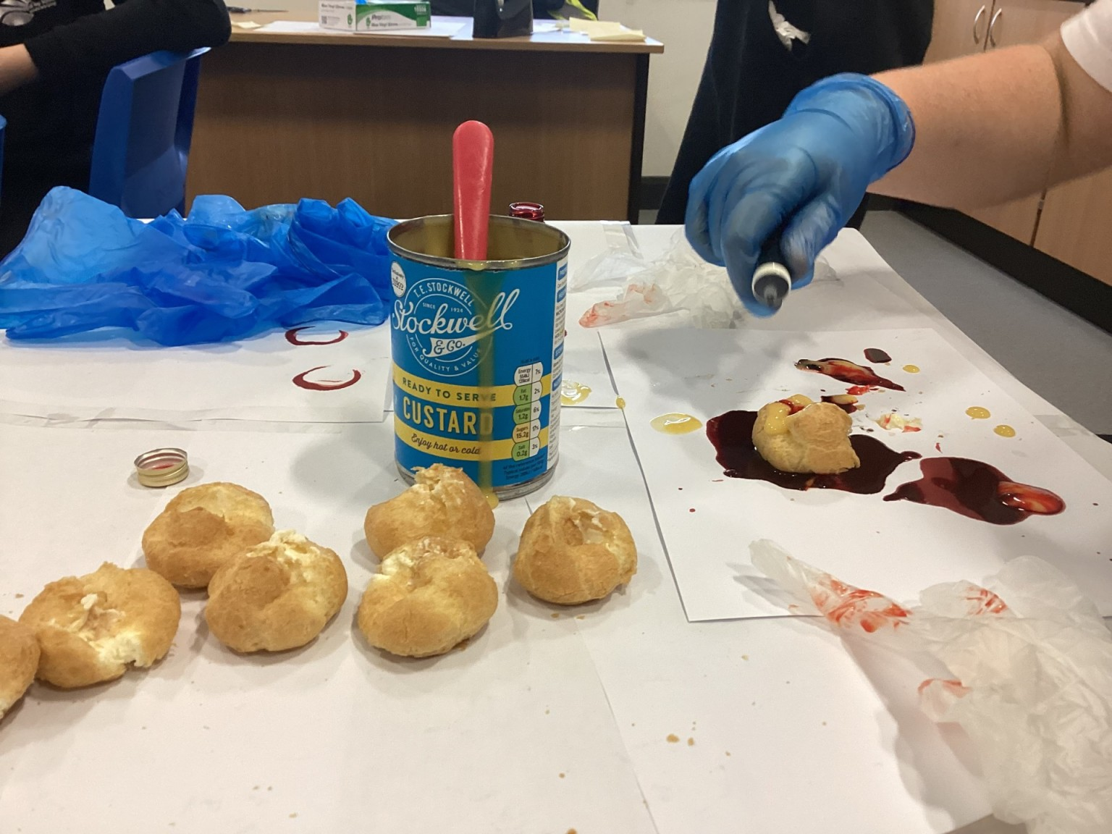
3D Class Blog

Welcome to 3D's class blog. Here you will see regular updates from our class giving you an insight into the work we get up to.
30/06/25
Monday : Over the last few weeks in P.E we have been preparing for the school sports day on Friday 4th July. In maths we are still practicing addition, subtraction and multiplication.Humanities consisted of climate change simulations. How many years it takes for a school to submerge.
Tuesday: Roald Dalh has been the topic for this half term. We learnt a lot about Roald Dalh's life and created a fact file. This week in Drama 3D have been doing some phenomenal work with monologue: taking a line from written monologue and adding their personal improvisation into it to make it uniquely theirs. They are working towards performing with conviction and focus next week for their finale for the year. Superb work 3D.
Wednesday: Science is a continuation on renewable and non renewable sources. Art is finishing off portraits.
Thursday: PSHE we have looked at xenophobia, racism and extreme nationalism, why are they so dangerous in Britain.
Friday : Sports day has arrived "good luck everyone
23/05/25
Maths - we are looking at digit column calculations with or without exchanging.
P.E - on Wednesday 21st there was an inter house cricket event in school. Yellow team won
R.E - we took part in the Holocaust 365 Project. This involved virtual reality head sets. We learnt about a holocaust survivor called Manfred Goldberg his brother Herman and his mum and dad. We joined them on their journey to a concentration camp during World War 2. Thank you, Mrs Whitehead for giving us this opportunity.
Food Tech - a continuation of using the air fryers. We cooked tater tots, burger, pitta bread, salad and spices

09/05/25
This was a short week due to Bank Holiday Monday.
English - was a continuation of poetry - poetree. We did shape poems 3D decided on a tree
Maths - number bonds within 100
Drama - 3D have been honing their skills on their chosen instruments and playing together like a real band.
P.E - tennis is the theme for this half term
Science - some excellent progress has been made in investigating living things and their habitat.
Food Tech - we made pizza wraps successfully in the air fryer.
P.S.H.E - work skills and the working environment .
We finished the week off with an imuse session followed by swimming and PLL not forgetting the book Fayre.

04/04/25
Monday is here again so we eased ourselves into P.E still focusing on our individual gymnastics routine. Then in humanities we watched a video on The Great fire of Newcastle and Gateshead 1854. The english lesson consisted of some great rhyming words. Then in maths continued expanding our knowledge on number bonds 10/20/50/100. A big congratulations in RE to EM he won the Easter egg for knowing the most related words to Judaism. Drama was scary it will all be revealed in next weeks blog! In science we looked at the digestive system and how it works, how food moves from the mouth down the oesophagus into the stomach then the small and large intestine then the rectum. Our budding artists did a pencil sketch of the mouth for art. We had a session in the new sensory room and the soft play area, it was great fun.

28/03/25
Another busy week for pupils in 3D. Monday kicked off with P.E where we started to compose a gymnastic routine to a piece of music of our choice . We all worked hard at this.
Maths comprised of 2D and 3D shape a continuation of work we started last week. Then we moved on to Tessellation .
We did a Time Line in R.E of Judaism/muslim and why Jerusalem is so ,important to them.
Humanities consisted of early medicines in the Middle Ages. We learnt about the 4 Humors black bile, yellow bile, phlegm and blood.
In English we identified and used onomatopoeia words in writing and also looked at alliteration.
Science was focused on nutrition and healthy eating also looking at food labels.
We finished off our week with a swim and PLL. Also we had a member of our class participate in the dance festival at the Sage, a huge "Well done" to all from 3D.

07/02/25
Monday for R.E we talked about Abraham and his son Isaac. Instead of Abraham sacrificing his son to God he slaughtered a lamb.
Tuesday some excellent progress has been made in maths recognition and writing decimal equivalents. Wednesday in science we talked about planning an investigation. What is a fare test an aim and a conclusion/ evaluation. I can describe different types of switches . In food tech most of us are working independently collecting our equipment weighing to make pastry and using a hot oven. Delicious sausages rolls were created.
Thursday we continued with the sound theme in drama.
Then we welcomed Friday swimming and enterprise.
31/01/25
This week we celebrated Chinese New Year, the year of the snake. School put on some lovely Chinese food to try: sweet & sour chicken bites, veggie curry and prawn crackers to name a few. We had some fun in science making circuits. In Humanities, we are looking at the plague so we made buboes (boils) out of profiter, custard and black and red food colouring, then some pupils popped them and were brave enough to eat them.
24/01/25
This week in maths we did number bonds to 100. Then in English we read the first four chapters of Street Child then worked on objectives. In PE we did a type of darts that is hundred times bigger than a standard darts board we used sticky balls instead of darts. On Wednesday some pupils from our class took part in a swimming Gala against other schools we all came back with medals. That is all for this week folks. See you next time. Gamer J and SLS
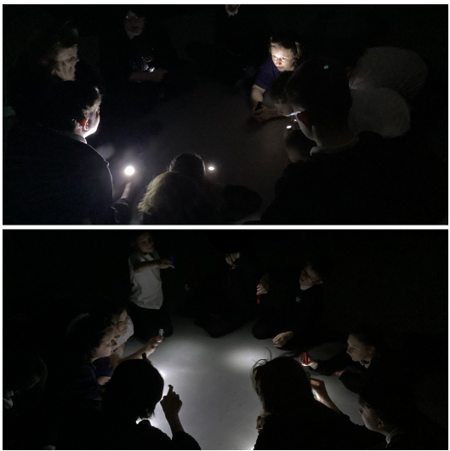
17/01/25
This week in 3D we are reading "Street Child set in the Victorian times. The book is by Berlie Doherty which ties in nicely with the trip we have just booked with 3E for the 14th February 2025 to Beamish Museum.
In Maths we have been doing fractions. Last week we did number bonds to 10 and 20.

This week's weather has been cold and rainy with a little bit of sunshine, but last week's weather was like an ice queen froze our school. We ended up staying in our classrooms, but some students went outside for some fresh air.

Then in drama we have been making great progress in playing the keyboards, learning hand positions, keys and timing. In PE we have started to do a darts tournament and in science we are starting electricity.

Finally in our assembly we learned about the pros and cons of peer pressure and in food tech we're doing beans and sausage pasty.

From reporters Gamer-J and SLS

10/01/25
We have all returned after the Christmas holiday but we thought we would share with you what we got up to at the end of last term. We have chosen to have class reporters and take responsibility for writing the blog ourselves.
The Blog before Christmas
Hello this is 3D and we are going to tell you what we did on the last week before xmas. On the last week on Monday we went to a cinema to see Moana 2 and the class enjoyed it very much and liked the singing and dramatic scenes in the movie.
Then we went to Burger King and the class got to choose what they wanted from there. We enjoyed our meals so much that most of the food was gone and we were very full.
And then on Wednesday, we had Christmas dinner with the teachers and we got to pull Christmas crackers and tell silly jokes. Then later that day we had a disco, and everyone loved the music, and everyone did interesting dances. On Friday we had a little party in our classroom with cake, crisps and more, we watched the Red One. Then the Grinch ran into the classroom and scared JN so much that he ran to the other side of the classroom. When the Grinch left the classroom we all laughed and chuckled. We hope you liked our weekly blog, see you next week.
Speak soon
From reporter Gamer JN and Reporter SLS.

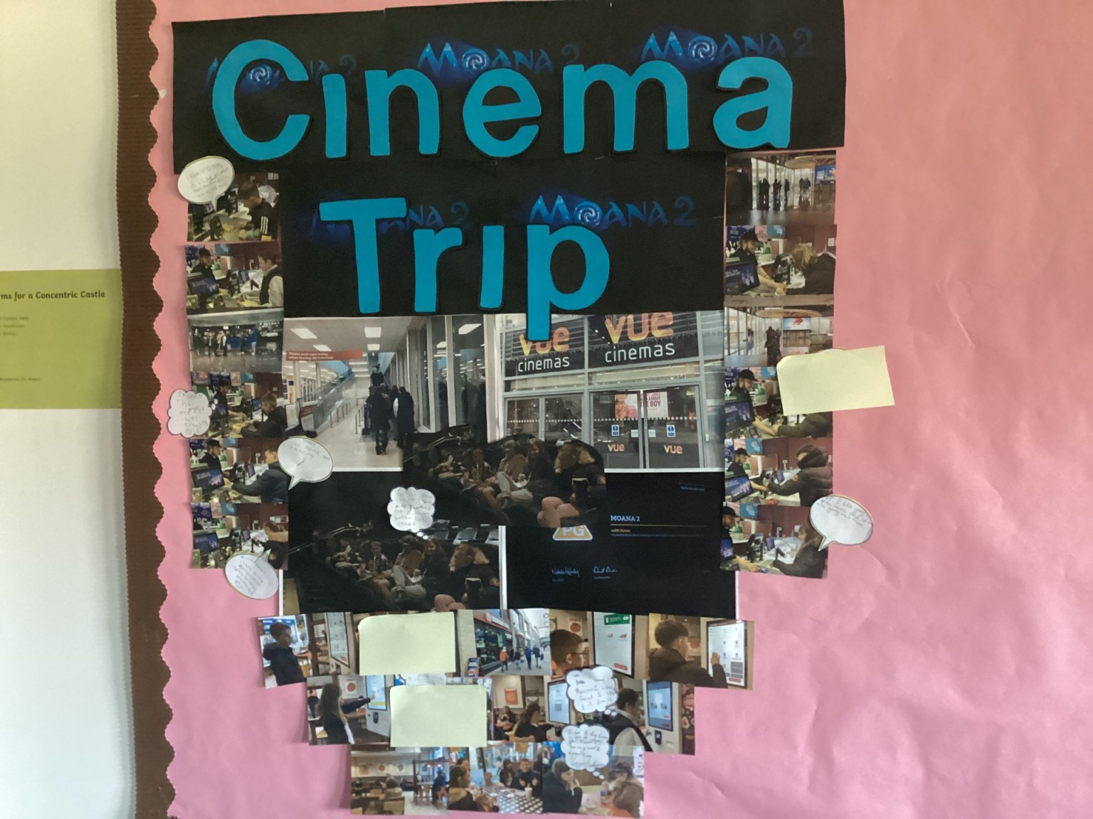
29/11/24
This week we have learned about skeletons in science.
In English we have been practicing contractions.
In Maths we have been colouring to show the answers to times tables questions.
In Independent Living we have been learning how to use a washing machine
KS won a certificate for helping out in the classroom.
JN won a certificate for good work in science.
See you all next week
by
KS (student)

