Class 3B class blog 24-25

'This week 3B enjoyed a treat this week. We all went to South Shields for a day of fun. We competed well in a mini golf tournament with some chill time on the beach. We obviously took a stop off at McDonalds on the way back to cool off. Everyone had fun and enjoyed a 3B bus karaoke, on the return trip to school.'
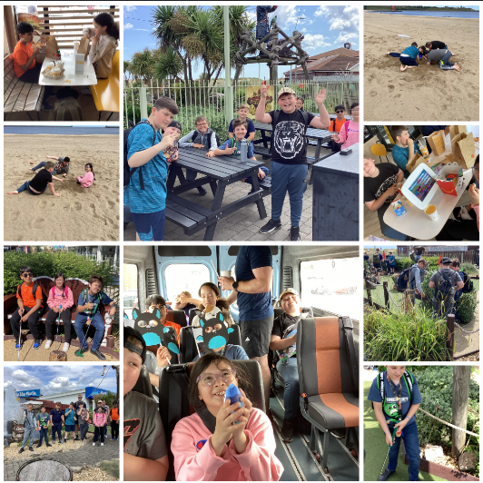
06/06/25
Another fab week in 3B.
In English we started to look at our final text of the year, the BFG. We enjoyed learning all about Roald Dahl.
In Maths we have consolidated learning linked to time and we have all done so well.
Our topic highlights this week were in Science and PSHE. We loved making our own board games using magnetism. We enjoyed testing them and improving our designs.
In PSHE we worked so well in teams to create some posters to raise awareness of the issues with the over consumption of energy drinks.
Great work in 3B
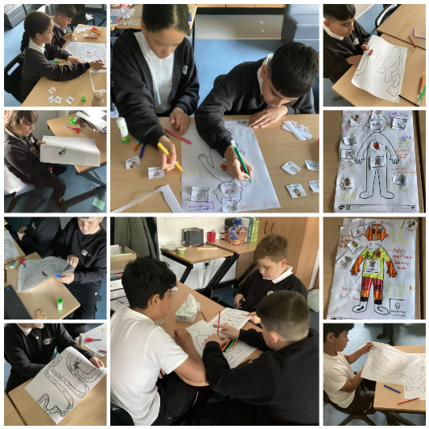
16/05/25
'3B have been working very well on their ILS topic this term. We have been learning how to plan journeys on both public and personal transport. We have been that amazing learning how to read bus and train timetables that we deserved a reward. As a group, we planned a class trip. We researched local locations and planned the timings for the day. We chose to visit Penshaw Monument and Herrington Park as a healthy choice. We took part in a walk with choosing time and ice cream in the park after! We are looking forward to planning more trips in Summer 2.'
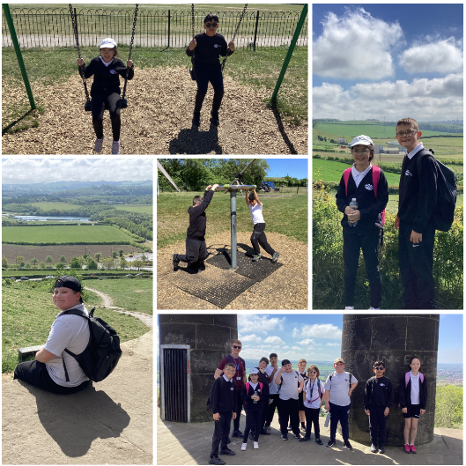
28/03/25
'3B had another fantastic week last week. Our main highlight was a lovely trip to Gibside National Trust. We linked the day to our mental health topic in PSHE. We enjoyed working in teams to map read and build dens. We also loved taking part in mindfulness techniques during our nature walk. We then finished the day off having fun in the park!'
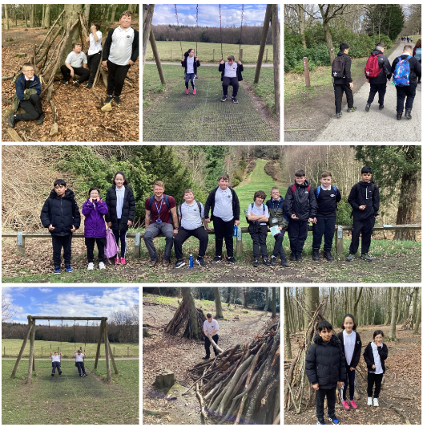
14/03/25
Class 3B really enjoyed their ILS lesson this week where they looked at safety linked to changing light bulbs. We changed a range of light bulbs ourselves to test their knowledge. Also, a congratulations to our stars of the week this week too. Well done LW, AW and DK.'
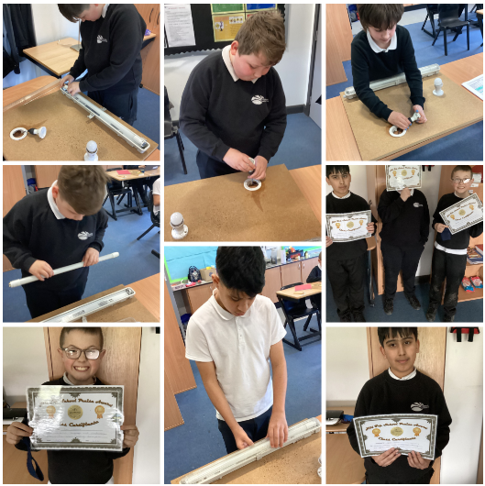
07/03/25
A quick whistle stop tour of the last few weeks in 3B.
Although we loved making money in our Enterprise project, we also loved spending it. We loved soaking Mr Ellison and throwing wet sponges at him. We have also recently enjoyed two amazing trips to Lumley and Bamburgh Castle to support our History topic. We thoroughly enjoyed both visits.
This week we loved our World Book Day competition where we recreated book characters out of potatoes. Congratulations to LW on winning one of the prizes.
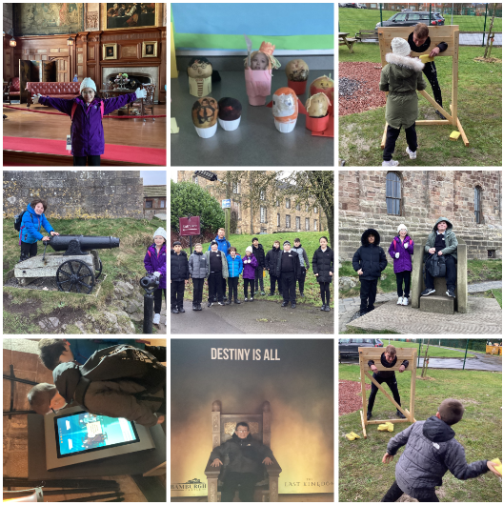
07/02/25
Another great week in 3B. We loved making pizzas this week and taste testing.
We finished the week raising awareness for children's Mental Health Week. We body mapped our strengths and hobbies along with making our own 'islands of personality' and comparing them to Riley's from Inside Out 2.
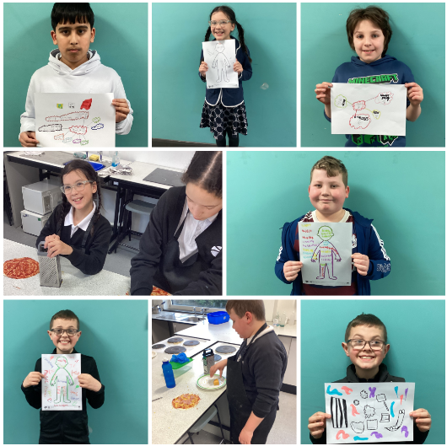
31/01/25
Here is a quick summary of another busy week in 3B.
We have continued to develop our programming skills and this week, we created our own maps, with added obstacles.
This week in Cookery we loved making our own cookies. We did so well to use the ovens safely and obviously, taste test our creations!
We have continued to really enjoy our Space Science topic. This week, we took part in a role-play session acting out key moments in scientific theories, linked to Space.
We finished the week wishing one of our friends a happy birthday. We also learned how to sign, whilst singing the song to our friend.

Great work 3B.

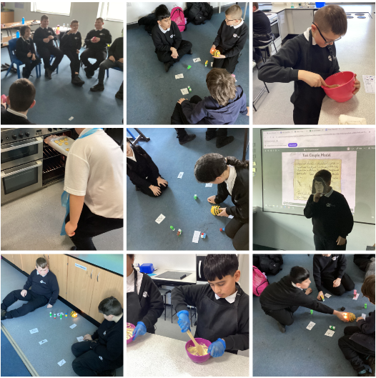
24/01/25
This week's highlight in 3B was certainly in Food Tech. Our independence and confidence has progressed so much since September. We used the frying pans independently this week and made some delicious quesadillas.
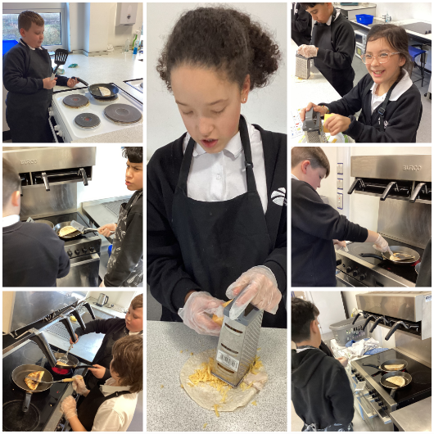

06/06/25
Another fab week in 3B.
In English we started to look at our final text of the year, the BFG. We enjoyed learning all about Roald Dahl.
In Maths we have consolidated learning linked to time and we have all done so well.
Our topic highlights this week were in Science and PSHE. We loved making our own board games using magnetism. We enjoyed testing them and improving our designs.
In PSHE we worked so well in teams to create some posters to raise awareness of the issues with the over consumption of energy drinks.
Great work in 3B
6th June 2025
16/05/25
'3B have been working very well on their ILS topic this term. We have been learning how to plan journeys on both public and personal transport. We have been that amazing learning how to read bus and train timetables that we deserved a reward. As a group, we planned a class trip. We researched local locations and planned the timings for the day. We chose to visit Penshaw Monument and Herrington Park as a healthy choice. We took part in a walk with choosing time and ice cream in the park after! We are looking forward to planning more trips in Summer 2.'
16/05/25

28/03/25
'3B had another fantastic week last week. Our main highlight was a lovely trip to Gibside National Trust. We linked the day to our mental health topic in PSHE. We enjoyed working in teams to map read and build dens. We also loved taking part in mindfulness techniques during our nature walk. We then finished the day off having fun in the park!'
28th March 2025

14/03/25
Class 3B really enjoyed their ILS lesson this week where they looked at safety linked to changing light bulbs. We changed a range of light bulbs ourselves to test their knowledge. Also, a congratulations to our stars of the week this week too. Well done LW, AW and DK.'
14th March 2025

07/03/25
A quick whistle stop tour of the last few weeks in 3B.
Although we loved making money in our Enterprise project, we also loved spending it. We loved soaking Mr Ellison and throwing wet sponges at him. We have also recently enjoyed two amazing trips to Lumley and Bamburgh Castle to support our History topic. We thoroughly enjoyed both visits.
This week we loved our World Book Day competition where we recreated book characters out of potatoes. Congratulations to LW on winning one of the prizes.
07/02/25
Another great week in 3B. We loved making pizzas this week and taste testing.
We finished the week raising awareness for children's Mental Health Week. We body mapped our strengths and hobbies along with making our own 'islands of personality' and comparing them to Riley's from Inside Out 2.
7th February 2025

31/01/25
Here is a quick summary of another busy week in 3B.
We have continued to develop our programming skills and this week, we created our own maps, with added obstacles.
This week in Cookery we loved making our own cookies. We did so well to use the ovens safely and obviously, taste test our creations!
We have continued to really enjoy our Space Science topic. This week, we took part in a role-play session acting out key moments in scientific theories, linked to Space.
We finished the week wishing one of our friends a happy birthday. We also learned how to sign, whilst singing the song to our friend.

Great work 3B.

24/01/25
This week's highlight in 3B was certainly in Food Tech. Our independence and confidence has progressed so much since September. We used the frying pans independently this week and made some delicious quesadillas.

17/01/25
Another great week in 3B.

We have completed so many teamwork challenges this week within our curriculum. We have worked well in teams, to sort clothes according to washing instructions in ILS. We have done so well working in teams to complete a range of budgeting challenges in PSHE. Finally, we have quizzed it out in History and Science, testing our knowledge on castles and Space.
A genuine well done to the whole class this week for cooperating and working so well with their friends.
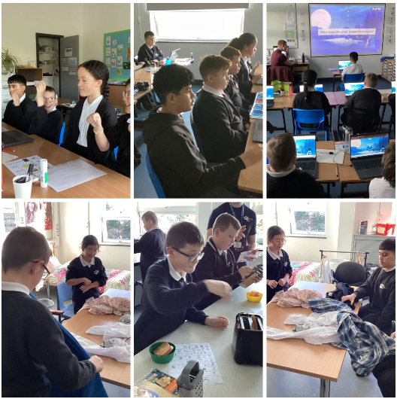

10/01/25
3B have had a great first week back. We have enjoyed discovering our new topics, especially in ICT and History. We all enjoyed our instructions lesson linked to programming where we directed our friends around class. We also began our castles topics with a competition. We had to draw and label our images with as much information as possible. We hope you like the winners. Also, a special mention to MAA, JS and LW in their efforts in the Bleep Test this week. Amazing.'
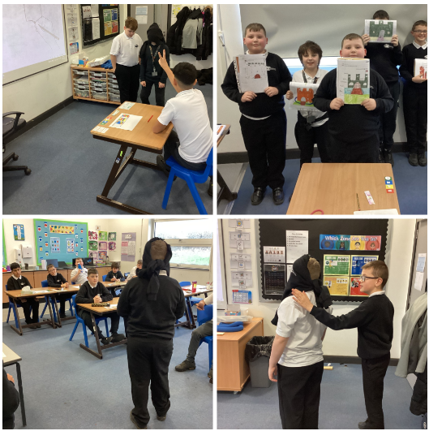

06/12/24
'3B have had another busy week. We have continued to work on our road safety skills in ILS. In PSHE, we completed some discussion work around making good decisions whilst using social media. In Art we made links to our RE topic of Buddhism. We tried so hard to learn about and sketch Ganesh. We hope you like some of our sketches! We finished the week comparing and sorting formal and informal language, ready for our letter writing next week. Great work here in 3B
29/11/24
'3B have had a lovely week. We have continued to work on our independence in the community, in ILS. We planned a route to the shops and purchased shop items with a set budget. In Science we have continued to look at life processes. This week, we analysed and observed animal cells, using the Bio viewers. We made a range of excellent scientific observations. '
