3A class blog 2024/25
13/06/2025
Our highlights for this week
OG – Holy Communion
OG told us all about his Holy Communion and made a quiz to check his classmates' understanding. His communication skills were fabulous and we all loved his quiz.
Maths – Doubling and adding up to 100, recording the information in a table, adding and taking away ten from any number. Playing our new target game.
We have been studying Sikhism and consolidated our knowledge of the 5ks :
Kirpan – sword- SE
Kachera – shorts- AM
Kesh – long hair – JS – covered by turban.
Kanga – comb – SE
Kara – bracelet.
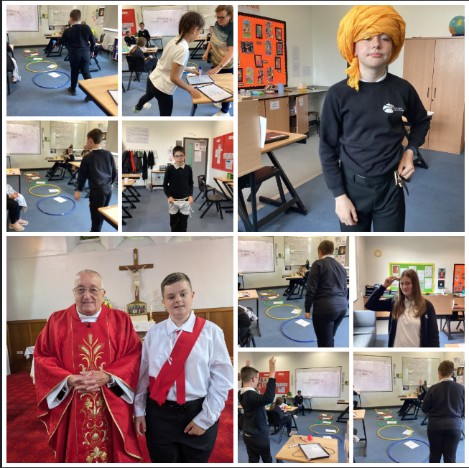
06/06/2025
Over the last few weeks in science, we have been experimenting with forces. We used force meters to measure the force of different objects, made and tested parachutes and recognised which objects are magnetic.
In maths, we have been practising addition and subtraction by playing a target game. We could also double the numbers to improve our scores.
In ILS. We have been planning a journey to Holmside park and some of the pupils volunteered to call the park. In cooking, we made biscuits – and we will continue to improve the recipe.
In History we have looked at the life of Anne Frank in preparation for her birthday on June 12th.
In RE, we are studying Sikhism and have learnt about the 5 ks and the Golden Temple of Amritsar.
We started to read the BFG and have worked in groups to write a fact file about Roald Dahl.
In PE we have been practising athletics events for sports day. Oem pupils have participated in rehearsals for the summer performance.
04/04/2025
In science we simulated an earthquake using soil, cloth and monopoly house. It helped to see how tectonic plates work.
In maths, we have neem measuring in centimetres using a ruler. We have also talked about millimetres, metres and kilometres.
In ILS, we have been talking about recycling and how a recycling plant works. One student wanted to see a landfill site so we watched a video about this. We know that too much rubbish can create pollution.
In cooking, we made scones – hey were really tasty. Some students made lots of smaller ones whilst others made a few larger ones.
In History we added the finishing touches to our castle including decoration, farms, drawbridges and moats.
In English we have been learning to write expanded noun phrases e.g. the poor, lonely orphans.
In PE we played curling and parkour. Two pupils went to the Boccia tournament in Killingworth.
We have looked at emotions in PSHE and made a class emotions book. In RE, we learnt the Easter story.

28/03/2025
1) Dance festival
We went to the Glasshouse Gateshead to perform our we were amazing. dance to “Fight for this love.”
2) Reading
One of our pupils took part in the reading development day and everybody is so proud of his progress. We done to this young man.
3) Dr Barnado
We are learning about Dr Barnado and his work helping orphan children.
4) Castles
In history, we were building castles in groups. We really enjoyed it and made some brilliant constructions.
5) Rock formation with sweeties.
We turned starburst sweeties into “Sedimentary, metamorphic and igneous rocks.”
6) Cooking
We made fairy cakes again, trying to improve on our cooking skills and trying to be more independent.
7) Sound bath
It was really good. We listened to gongs and chimes. It was very relaxing. Some of us fell asleep.
8) Timetables problems
In maths, we have been doing timetables and learning how to solve word problems.
9) In ILS, we were learning how to empty bins safely and can list what we need to do to be safe.
10) In PSHE, we have been learning about our bodies including puberty.
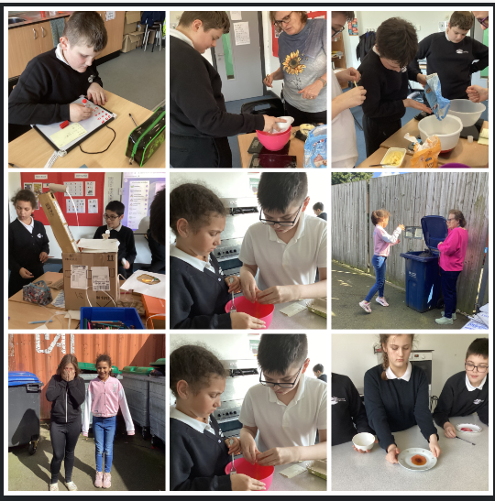
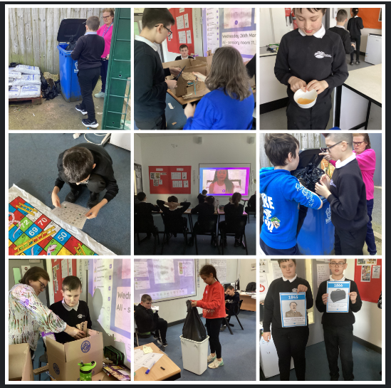
14/03/2025
This week, we celebrated one of our pupils gaining an extreme reading award – next to Tommy in Seaham, whilst one was able to buy himself a Ferrari using his attendance prize – just a toy – sorry!
The pupils have continued to consolidate their work on money, playing games to learn how to make different amounts of money.
We tested rocks in science and compared them. In history, we presented castle plans to each other, using speaking and listening skills to good effect. In ILS, the pupils have discussed the chores they do at home – some more than others! JC is keen to start shopping and JS helps to tidy his Lego away.
We are slowly making our way through Street child and the pupils are keen to find out what happens to Jim Jarvis. In PSHE, we are finding out about how to cope with different emotions, focusing on anger this week.
In RE. we are using hand signs to learn and remember the ten commandments and have continued to develop our skills in ICT using word and PowerPoint.
We have spent some time in the new sensory room and the pupils are enjoying this very much and responding to the sensory input.
21/02/2025
The pupils have been showing what they have learnt this half term using an English and maths learning mat. Some great progress in fractions and super use of spelling, punctuation and grammar in English. Pupils have understood what the workhouse would be like and chosen appropriate adjectives.
We have learnt to use an ironing board in ILS and the pupils each used the vending machine at the swimming pool to purchase a tasty treat.
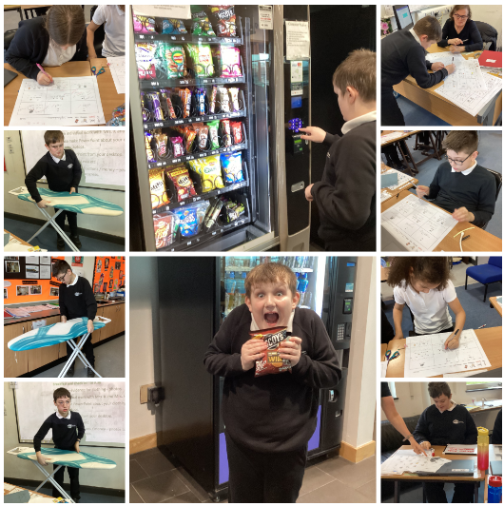
14/02/2025
PE - practising their boccia skills for the Boccia tournament next week.

History - the feudal system - we all took a role as a peasant, knight, lord of king and recognised why the system was important.

Enterprise - we have made about £30 thus far selling out water and are honing our selling skills.

In PSHE and ICT, we have been learning to order products AND compare prices of different supermarkets.

Maths - some great work on fractions

English - We have been adding -ing to verbs and writing sentences. We have also added some dialogue to our "Street child" roleplay photos.

In science we can name the different phases of the moon and identify whether it is waxing or waning.
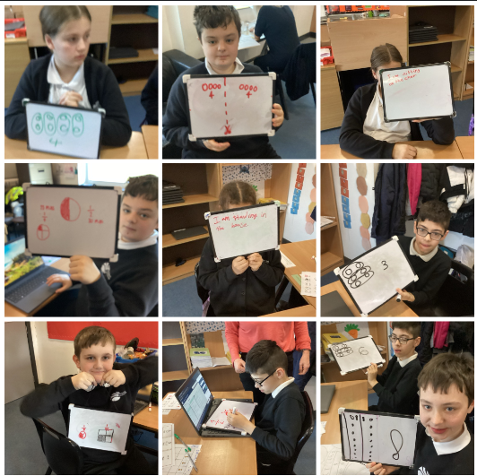
07/02/2025
Some great work this week especially in English where the pupils have been practisng their drama skills. They are learning what it would be like to be poor in Victorian times and what woyuld happen if you could not work! WE have made some lovely videos
In ILS, pupils have looked at labels and decided how to wash particular items. We know why some items cannot be washed, bleached or ironed.
PSHE We learned how to order items online and how shopping at different shops can help us to save money.
Swimming We have continued to show independence in the swimming pool and during changing.
The Apprentice We have started selling our water this week – 3a Coolest Water at 50p per bottle. Stocks are selling fast so if you would like a bottle, send in your 50p!
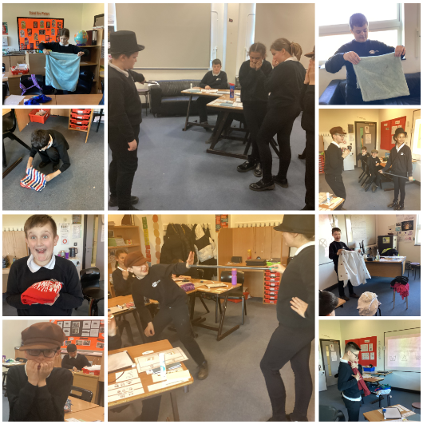
31/01/25
3a have had a really good week – we are all concentrating on a strong start and responding very well to this- despite the very windy weather!!
Science: We made a fact file for our favourite planets then presented these to the class
English: We have been reading Street child, describing Jim Jarvis and choosing similar words to those in the text.
Maths: Adding and subtracting number to 100 then above 100! WE know that we can add in any order but its easier to start with biggest number. In fast maths, we are adding 2 and 3 on to every number and subtracting too.
ILS: We are learning to look after our clothes by folding and looking at clothing labels.
PSHE: We have been learning why we have money and learning to prioritise what we buy.
Humanities: We watched an interview with Mala Tribich who was a prisoner during the Holocaust.
ICT and Art: We have been working on our Enterprise task using different media.

24/01/25
3a have had a really good week – we are all concentrating on a strong start and responding very well to this- despite the very windy weather!!
Science: We made a fact file for our favourite planets and then presented these to the class.
English: We have been reading Street Child, describing Jim Jarvis, and choosing similar words to those in the text.
Maths: Adding and subtracting numbers to 100, and then above 100! W2 know that we can add in any order but its easier to start with biggest number. In fast maths, we are adding 2 and 3 on to every number and subtracting too.
ILS: We are learning to look after our clothes by folding and looking at clothing labels.
PSHE: We have been learning why we have money and learning to prioritise what we buy.
Humanities: We watched an interview with Mala Tribich who was a prisoner during the Holocaust.
ICT and Art: We have been working on our Enterprise task using different media.
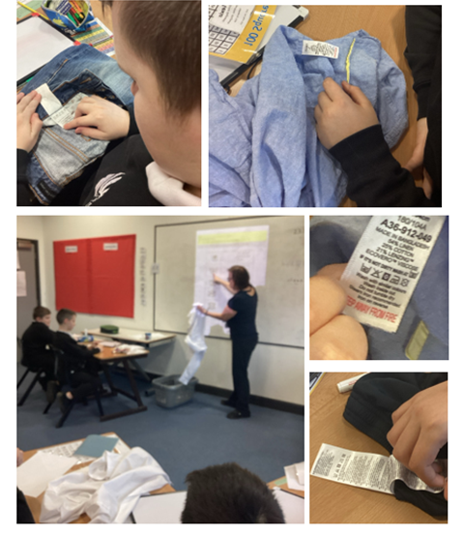
17/01/25
In English, we are learning how to use adjectives to describe characters and how to make longer sentences using conjunctions. We are starting to read Street child by Berlie Doherty.
In Maths, we are reviewing work on time: o’clock, half past and quarter to and past. Some of us can read all the times of the clock and convert to digital!
In Independent living skills we are starting to care for our clothes and Mrs. Kelly has been very impressed with how much we know!
We are learning to budget in PSHE and this is helping with our Enterprise activity - we would like to make enough money to go to Holmside Park.
We have also been learning about castles, keyboards, circuit training, the solar system and stained glass windows (Christianity).
We have returned to the swimming pool this week and we are so impressed with the behaviour!!
Well done 3a from Mrs Hymers and Mrs Kelly.
06/12/24
We have been playing time games and using new clocks that Mrs Dove gave us.
In science, we have looked at cells using a microscope.
We planned our own Anglo-Saxon village – some amazing designs.
In PE, we are learning to play basketball and in cooking, we used the hob to make scrambled egg, heat soup and make beans on toast.
In RE we were overlearning different religions and their festivals.
In PSHE, we watched Akeelah and the bee which covered racism and following your dreams.
In English, we wrote our own endings for Cloud tea monkeys. JC is getting very exasperated with Mrs Kelly because he really wants to hear the ending!!
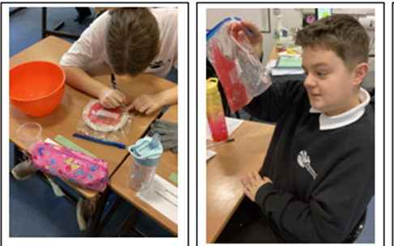

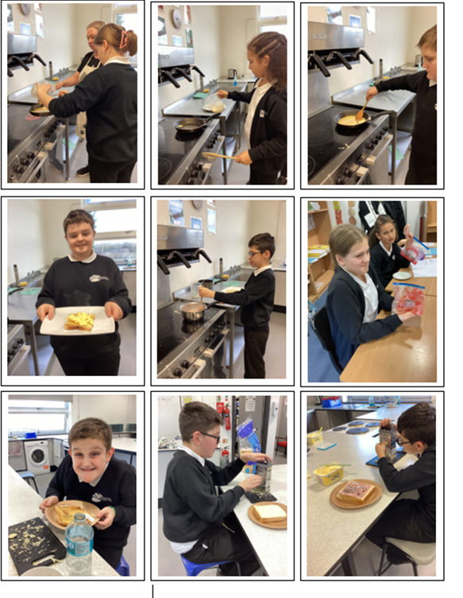

29/11/24
In maths this week, we have been learning to tell the time. We find it quite difficult, but we are trying really hard.
In English, we have written letters to our parents to invite them to 3a tea and coffee morning. We have almost finished “Cloud tea monkeys”, our text for this half term and have been using prepositions like inside, on, over and under.
In food technology, we were practising grating, cutting and spreading when we made toasties.
In ILS, we are learning to plan journeys and today we watched people cross the road incorrectly and we told them what they had done wrong.
This week, we were visited by the nurses for PSHE, who spoke to us about puberty and emotions. In Humanities, we have started to learn about Anglo-Saxons and where they came from – Germany, Denmark and Netherlands. We are also studying Hindu festivals. In PE, we played basketball and used the trampoline. Some of the class have been practising their singing for the Christmas performance. In science, we made cells from sweets including the nucleus, membrane, cytoplasm and mitochondria. In drama, we were visited by Tom from Lawnmowers; he played circle time games with us.

Christmas in Poland
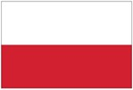

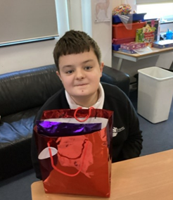
The Day of Saint Nicholas on 6 December is the unofficial beginning of the festive season in Poland. Well-behaved children receive small gifts on the day, whereas naughty children receive a lump of coal or a twig, called "rózga" (“roozga” ) OG received his first Christmas present today because he is a well-behaved young man!


