A6 Blogs 2025-26
27/06/25
We have had such a busy week in A6!
The pupils were able to have a small transition afternoon yesterday where they were able to access their new classes with new staff. The pupils all coped very well with the change.
In English, we completed our last session of 'Oi, get off our train!' and the pupils were able to sequence the story.
In maths, we continued to look at full and empty within capacity and introduced "half full"
In UTW, we continued with our castle sensory story.
In Life Skills, we continued to look at travelling in the community and some of our friends went to Hydro and some of us went on a trip to Riverside Park to see Lumley Castle and have fun in the castle play area.
In PSHE, we looked at how to keep our bodies safe.
In Food Technology, we made ham sandwiches.
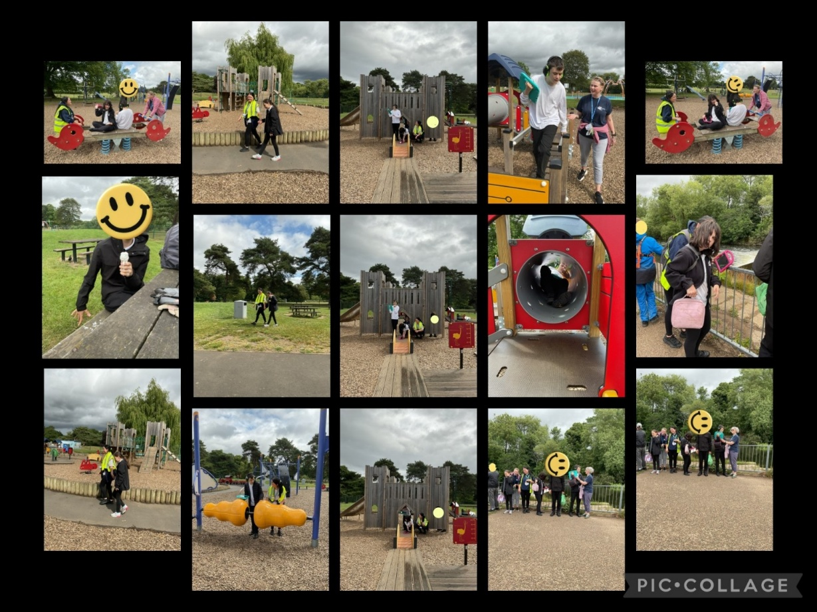
We also enjoyed a visit to the shop, attention autism sessions, phonics, sensory play, sensory room, I muse, soft play and movement room time.

20/06/25
We have had a lovely and very warm week in A6!
The pupils have coped very well with the hot weather this week and we are proud of them for being adaptable to the changes.
In English, we have continued to look at "Oi, get off our train!" where we looked at describing the different scenes in the story.
In Maths, we started a new topic of "full and empty" where the children explored sensory play to measure.
In UTW, we have continued to look at castles and took part in some sensory play of building castles in different ways.
In PSHE, we have continued to look at trusted adults.
In Life Skills, we have focused on preparing for trips in the community. We are looking forward to going to riverside park next week!
In Food Technology, we have continued to show independent skills in making ham sandwiches.
We have also taken part in regular phonics, attention autism, sensory room, I muse, soft play, movement room and movement breaks to our school MUGA.
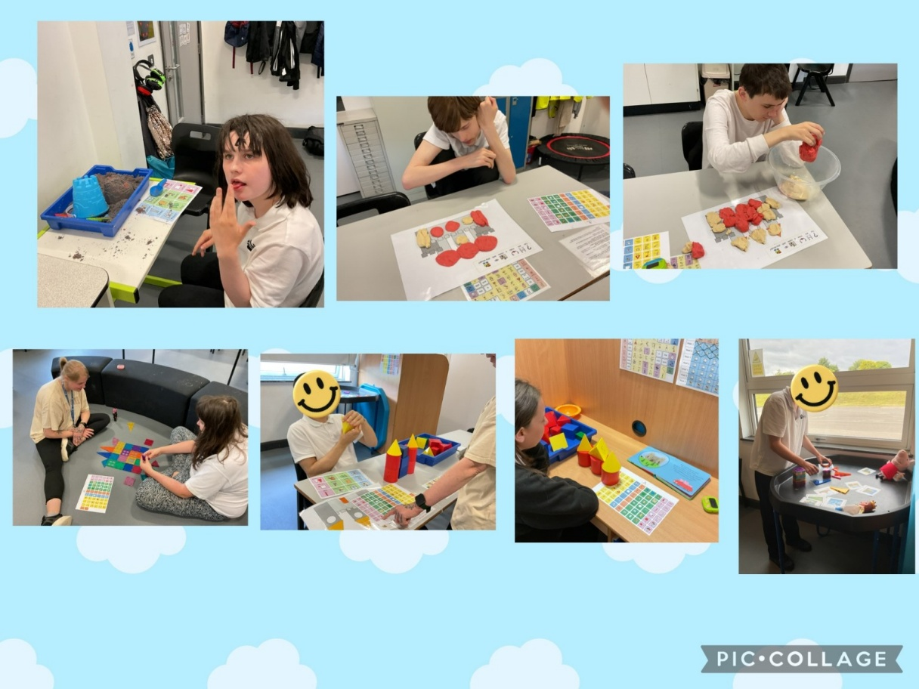

13/06/25
Well done A6 for another wonderful week! We can't believe there is only 5 weeks left at school. We are so proud of the children's progress over this academic year.
This week:
In English, we have looked at our sensory story "Oi get off our train!" and looked at the different characters within the story.
In Maths, we have continued with mass and looked at heavy, light and the same.
In UTW, we have started our new topic of 'Castles' and enjoyed our sensory story of Peppa going to a castle.
In PSHE, we have continued to look at trusted adults.
In Life Skills, we have been preparing for trips into the community.
In Food Technology, we have looked at making ham sandwiches.
We also enjoyed watching our performance on Wednesday with our peers in the hall. A big thank you to Miss Angus for making it so special!
We have also enjoyed regular attention autism, phonics, sensory play, story time, song time, movement room, sensory room, I muse and soft play.
Well done A6 👏🏻

06/06/25
What a lovely first week back A6 have had!
In English, we introduced a new story called "Oi! Get off our train".
In Maths, we have continued to look at Mass and looked at heavy, light and the same.
In PSHE, we have looked at keeping ourselves safe and who our trusted people are.
In UTW, we looked at our beanstalk for the last time and found were able to do a life cycle on the beanstalks.
In Life Skills, we have started to look at travel training in preparation for all the trips we're going on this term.
In Food Technology, we looked at our new topic of meat and looked at trying different meats that we will make sandwiches with.
In Attention Autism, we have looked at Pride Week.
In Sensory play, we completed some lovely turn taking with play related to our new topic 'castles'.
We have also enjoyed regular movement room time, sensory room, I muse, soft play and the shop.

23/05/25
A6 have had a wonderful week, and we are very proud of our children this term.
Although it has been a short half term, we have completed lots of work and made some fantastic progress.
This week:
In English, we have continued to look at the sensory story "Handa's Surprise" and looked at sequencing the story.
In Maths, we looked at heavy and light and were able to weigh items from Handa's Surprise.
In Understanding the World, we have continued to look at our beanstalks and can't believe how tall they have got!
In Life Skills, we continued at tooth brushing, and I am so proud of the progress the children have made in this.
In PSHE, we have continued to look at healthy eating and have enjoyed trying different vegetables.
In Community Skills, we have been to the shop and Hydro. We are looking forward to the different trips next term.
In Food Technology, we showed our confidence in making jam sandwiches.
We have also had regular phonics sessions, rebound sessions, sensory play, sensory room, I muse, soft play and movement room.
Have the best half term everyone!
A6 🙂

16/05/25
What a busy week A6 has had!
In English, we have continued to look at the story Handa's Surprise. We were able to describe the different fruit in the story.
In Maths, we have been working on the topic 'mass' and have been weighing the different fruits from Handa's Surprise.
In UTW, we have continued to focus on our beanstalks, and they have started to grow!!!
In Attention Autism, we have focused on World Mental Health Week.
In PSHE, we have continued to look at healthy foods and have been exploring different types of salad. You will see we were so brave touching and smelling them in the pictures.
In Food Tech, we continued to improve our independence skills and made jam sandwiches.
In Life Skills, we have continued to look at brushing our teeth.
In Community Skills, some of our pupils went to the shop and to Hydro.
We have also had regular soft play, sensory room, I muse, rebound, MUGA trips, phonics and sensory play.
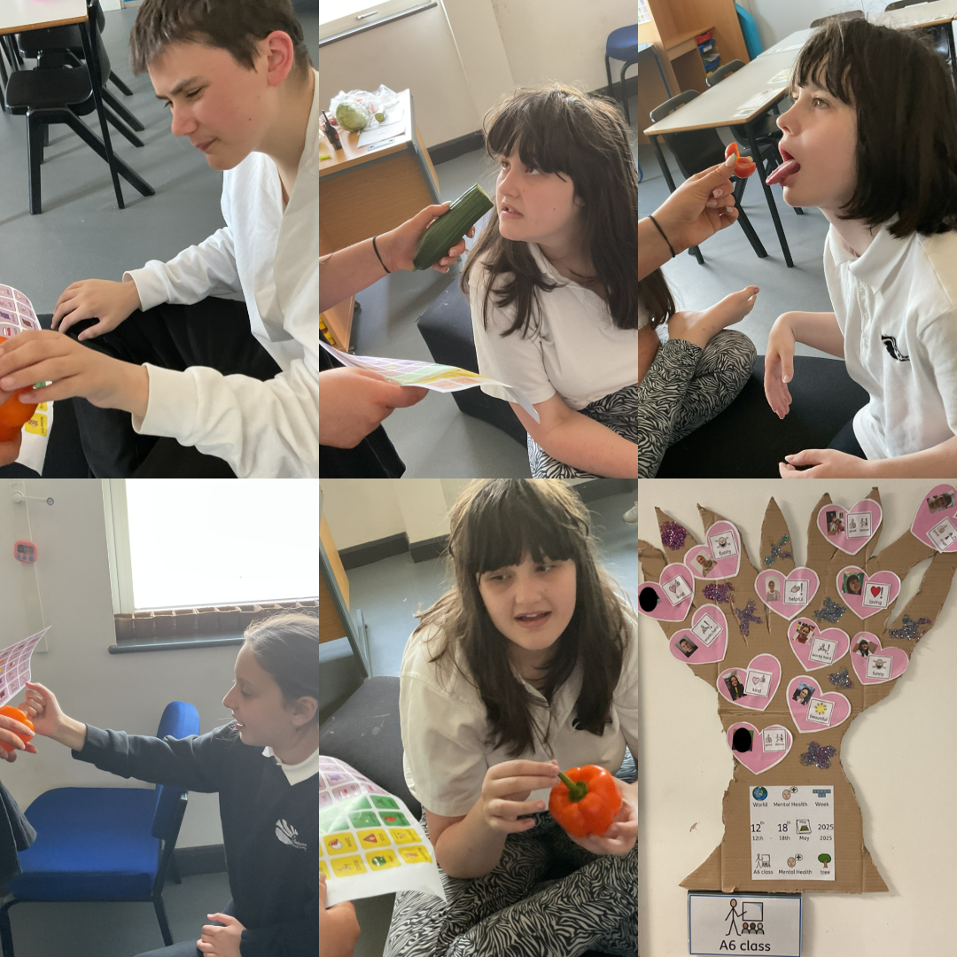

09/05/25
A6 class has had a lovey week, we have completing lots of lovely activities.
In English, we have continued with our new story "Handa's surprise". Our pupils found it very funny when the animals stole all of the delicious fruit!
In Maths, we have look at mass and how things are heavy and light with different fruits.
In UTW, we have continued reading our sensory story Jack and the Beanstalk and we have looked at our plan from the week before how to plant a beanstalk.
In Food Technology, we have looked at the story "The Giant Jam Sandwich" and are planning how to use our knife skills to make the best Jam sandwich.
In PSHE, we have been focusing on healthy eating and have used our senses to explore different fruits.
In sensory play we have looked at different links to growing - specifically with different fruits.
in Attention autism, we have learned about world mental health.
We have also completed lots of regular phonics sessions, movement room, rebound therapy, community skills, sensory room, I muse and soft play.

02/05/25
What a lovely first week back A6 had completing lots of lovely activities and settling back into routine.
In English, we have introduced our new story "Handa's surprise". Our pupils found it very funny when the animals stole all of the delicious fruit!
In Maths, we have started to look at mass and how things are heavy and light.
In UTW, we have looked at our new sensory story Jack and the Beanstalk and have planned how we are going to plant our beanstalks next week. We have attached some photos of our pupils enjoying the sensory story.
In Food Technology, we have looked at the story "The Giant Jam Sandwich" and are planning how to use our knife skills to make the best Jam sandwich.
In PSHE, we have been focusing on healthy eating and have used our senses to explore different fruits.
In sensory play we have looked at different links to growing - specifically with different fruits.
in Attention autism, we have learned about National Space Day and created some amazing space artwork.
We have also completed lots of regular phonics sessions, movement room, rebound therapy, community skills, sensory room, I muse and soft play.
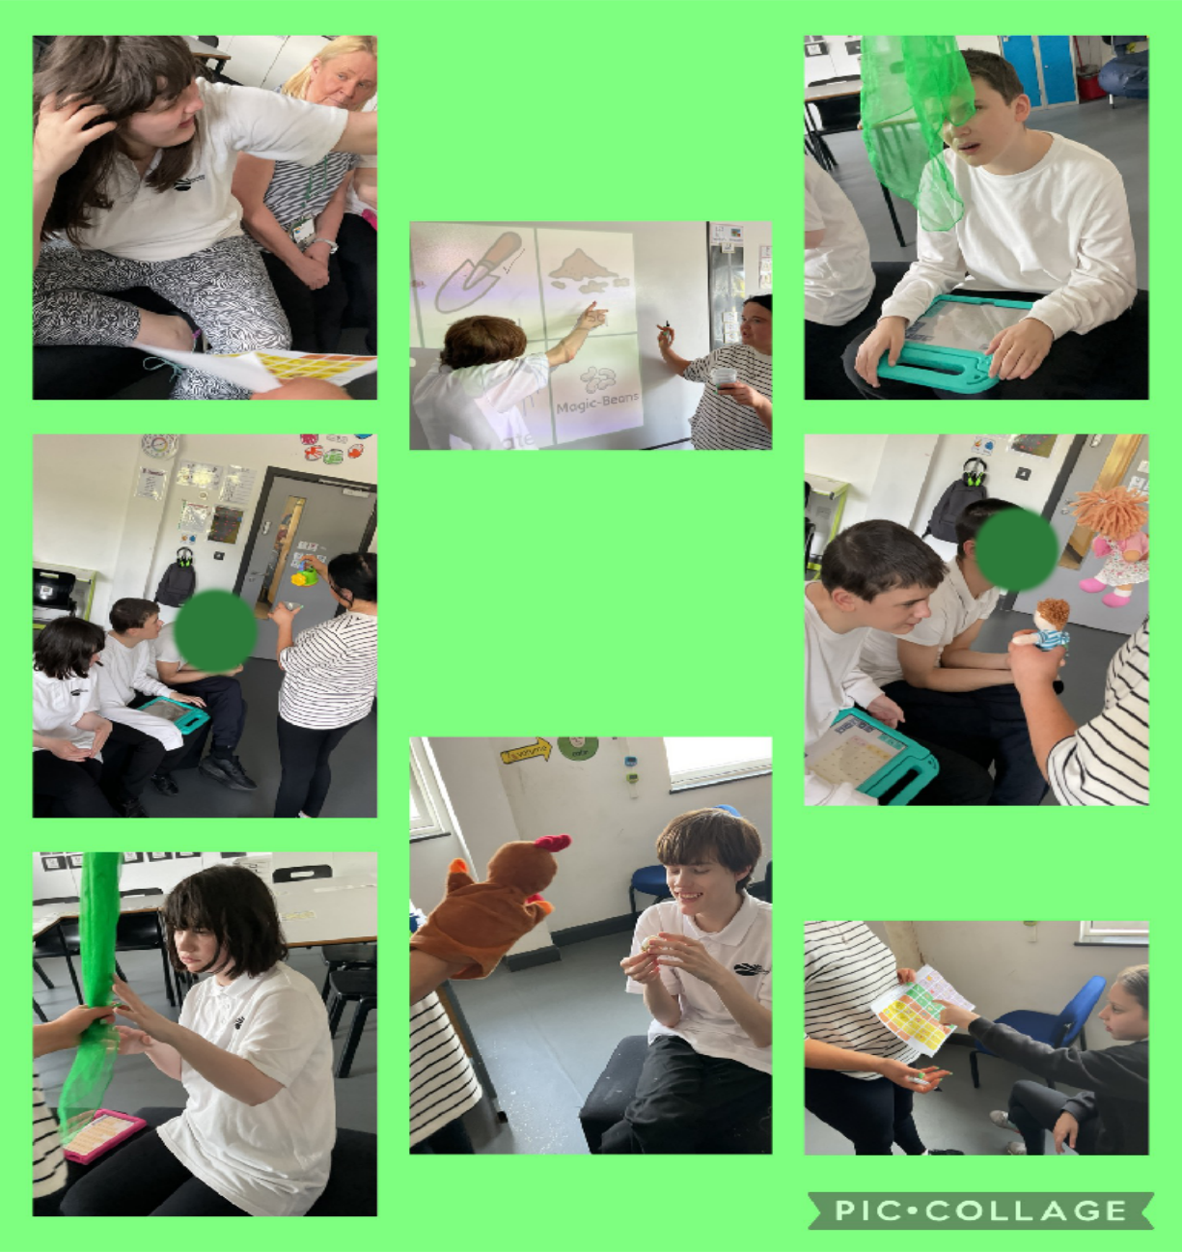

04/04/25
Hello from A6!
What a busy week we have had and we can't believe there is only one week left until Easter.
We have started celebrations this week and have looked at different spring and Easter sensory play, as well as celebrating Autism Awareness Week in our Attention Autism sessions.
In English, we have started our new story 'The Very Busy Spider' and have looked at why the spider is spinning his huge web.
In Maths, we have continued to look at money and have been focusing on counting our 1p, 2p, 5p, 10p, 20p coins.
In PSHE, we have looked at being kind to friends and have taken part in some lovely turn taking with one another.
In UTW, we recapped all our knowledge about the topic Hinduism.
In Life Skills, we have recapped all our knowledge about Road Safety.
In Community Skills, we enjoyed a trip to the shop.
In Poetry, we have looked at the song 'I plant the seed'.
We have also had lots of time at the sensory room, I muse, Soft play and movement room. As well as Rebound Therapy.
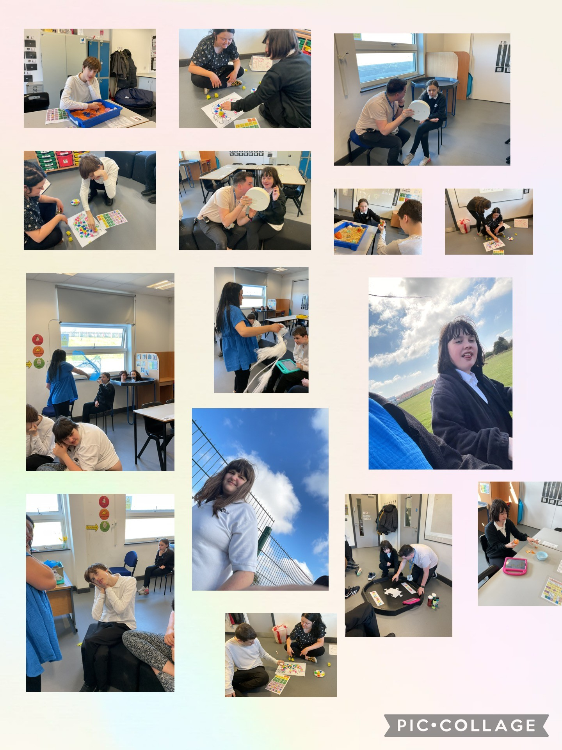

28/03/25
We had a lovely week in A6...
We have started spring celebrations and have looked at different spring sensory play, as well as celebrating Mother's Day.
In English, we have continued to look at our story 'Mr. Wolf's Pancakes' and what the characters are doing in the story.
In Maths, we have continued to look at money and have been focusing on the difference of p and £.
In PSHE, we have continued to look at good and bad choices.
In UTW, we continued with our topic of Hinduism. We have been looking at Holi festival and have been throwing paint!
In Life Skills, we have continued with road safety and have enjoyed looking at Zebra Crossings.
In Food Tech, we focused on the GingerBread Man from our sensory story.
In Community Skills, we enjoyed a trip to the shop.
In Poetry, we have looked at the song 'I hear Thunder'
We have also had lots of time at the sensory room, I muse, Soft play and movement room. As well as Rebound Therapy.
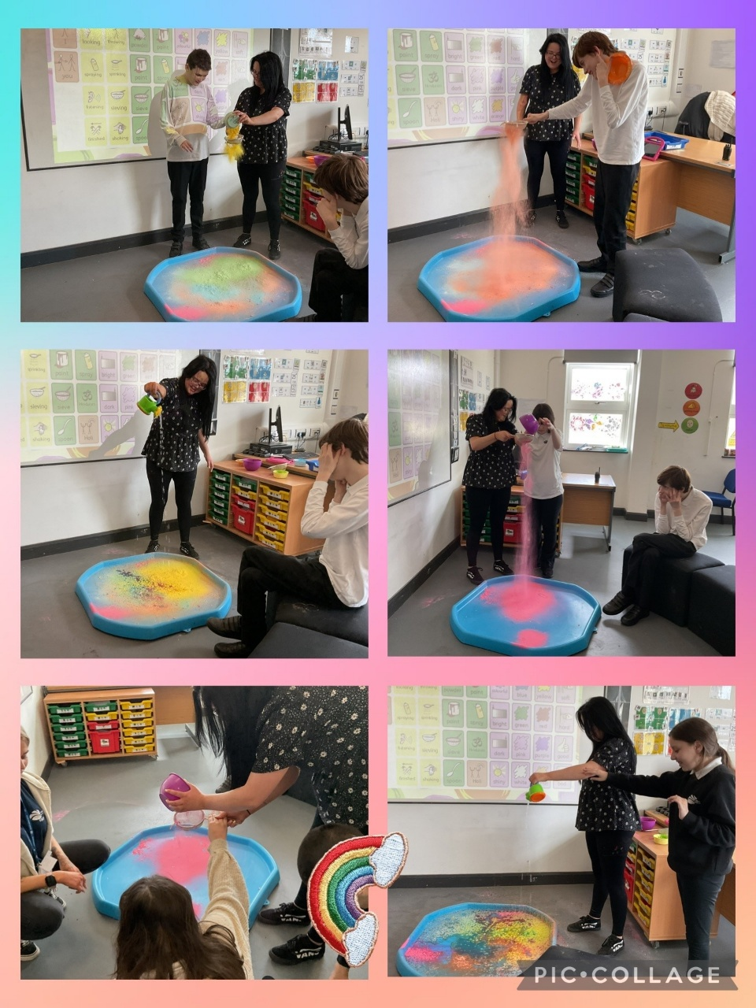

21/03/25
What a busy week we have had in A6.

We have started spring celebrations and have looked at different spring sensory play, as well as celebrating Red Nose Day and St Patrick's Day in our Attention Autism sessions.
In English, we have continued to look at our story 'Mr. Wolf's Pancakes' and have looked at 'who' is in the story.
In Maths, we have continued to look at money and have been focusing on £ notes.
In PSHE, we have continued to look at good and bad choices.
In UTW, we continued with our topic of Hinduism. We have been looking at Diwali and have made rangoli patterns with sand.
In Life Skills, we have continued with road safety and have enjoyed looking at Zebra Crossings.
In Food Tech, we pretended we were Mr Wolf from our sensory story and made delicious pancakes!
In Community Skills, we enjoyed a trip to the shop.
In Poetry, we have looked at the song '5 speckled frogs'.

We have also had lots of time at the sensory room, I muse, Soft play and movement room. As well as Rebound Therapy.

14/03/25
A6 have continued to show amazing progress and have had a lovely week.

In English, we have been looking at Mr Wolfs Pancakes, where we were able to label the front cover and describe some of the characters.
In maths, we have been focusing on money and recognising coins.
In UTW, we have been focusing on the topic Hinduism, where we created fireworks for Diwali.
In PSHE, we have been continuing to learn good and bad choices.
In Food Tech, we continued to learn things that we might find useful to make.
In Life Skills, we have been looking at road safety and this week have focused on what a traffic light is, and why they are important.
In poetry, we have continued to look at 5 little ducks and were able to sequence the poem.
In Attention Autism, we have looked at similar stories to our sensory story and have looked at exploring the Gingerbread Man and Chicken Licken.

We have also had regular I muse, soft play, sensory room, movement room, rebound, phonics and of course community skills. We are hoping to go to the park next Thursday once the weather picks up a little bit.

Another great week, well done A6!😃

07/03/25
We have had a lovely week in A6, exploring pancake day, world book day and of course the new sensory room and soft play!

In English, we have introduced our new sensory story "Mr Wolf's Pancakes".
In maths, we have started our new topic of money where we explored different coins.
In UTW, we have been looking at our new topic of Hinduism, where the pupils explored different sensory play, aswell as making Diya Lamps.
In PSHE, we have been learning about "good and bad choices"
In life skills, we have started our new topic of road safety where the pupils were able to sequence the routine of crossing a road.
In Attention Autism, we looked at our new poem/song of the week "5 little ducks" and also made pancakes for pancake day!
In Food Technology, we continued to focus on cooking things we will enjoy and Olivia was able to take the wrapper off a pizza and put it in the oven with some support. She then enjoyed eating it for snack.
We have also enjoyed Rebound Therapy, Movement room, Sensory Room, I muse and Soft play. The children loved exploring all of the new rooms!!
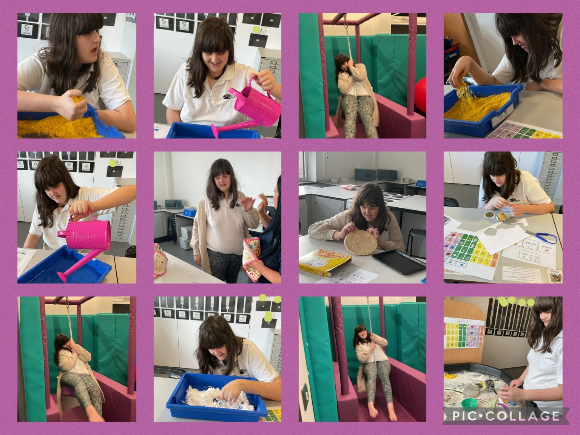

21/02/25
Just a little update about our week in A6.
In English, we have been looking at who is in the sensory story "monkey puzzle".
In maths, we have continued to look at symmetry and have been matching symmetry within characters in our sensory story.
In life skills, we have continued with tidying our home and have been very good at following instructions on how to tidy different areas.
We missed food technology this week due to us playing a Boccia tournament with some of our peers from different classes. We were amazing at waiting our turn!
In PSHE, we have continued to look at people who help us and have focused on dentists and how they keep us safe.
In understanding the world, we have been looking at leaders within our life in home and at school.
In Attention Autism, we have looked at links with our sensory story and have enjoyed completing Monkey Meditation and lots of lovely singing to 5 little monkeys!
In Art...
We have also completed regular sensory play, regular I muse and soft play, movement room, rebound and community skills! We are excited to start going to the park as part of our community skills after half term.
It has been an amazing half term for our class, and we are very proud of the progress they have made.
We hope you all have a lovely week off and thank you for all of your support,
Miss Collins, Mr Dixon, Miss Bradshaw and Miss Hutchinson
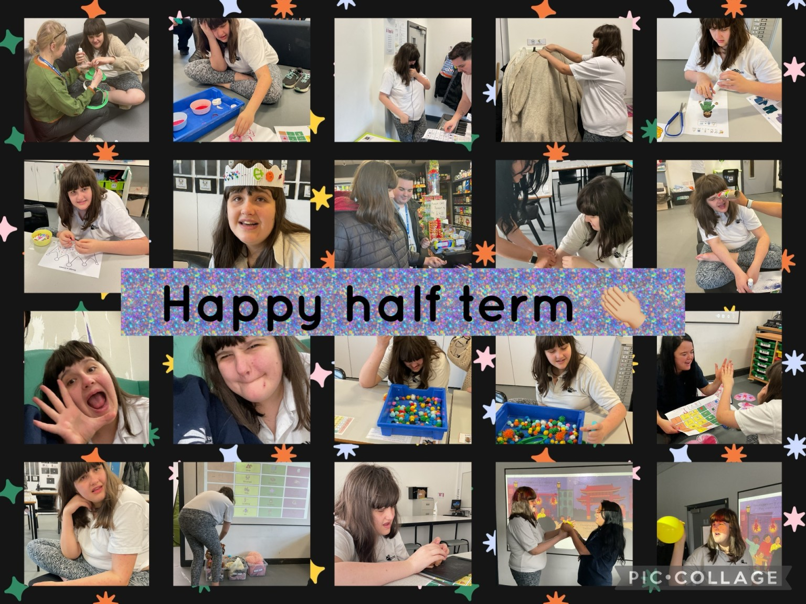

14/02/25
In A6 this week we have had a very busy week celebrating Valentines Day and completing amazing work.
In English, we have continued looking at our sensory story 'Monkey Puzzle' and have looked at different characters in the story.
In Maths, we have continued with symmetry and have enjoyed creating symmetrical butterflies and hearts.
In PSHE, we have continued to look at people who keep us safe and have looked at Police and Doctors.
In UTW, we have continued with Kings and Queens and have learnt some facts about Queen Elizabeth and King Charles.
In Food Technology, we started to look at things we might find useful to cook ourselves.
In Life Skills, we have continued with looking after our home.
In Community Skills, we have continued to go to Hydro and the shop.
We have also had regular sensory room sessions, Attention Autism sessions, I muse, Soft play, Rebound and sensory play.
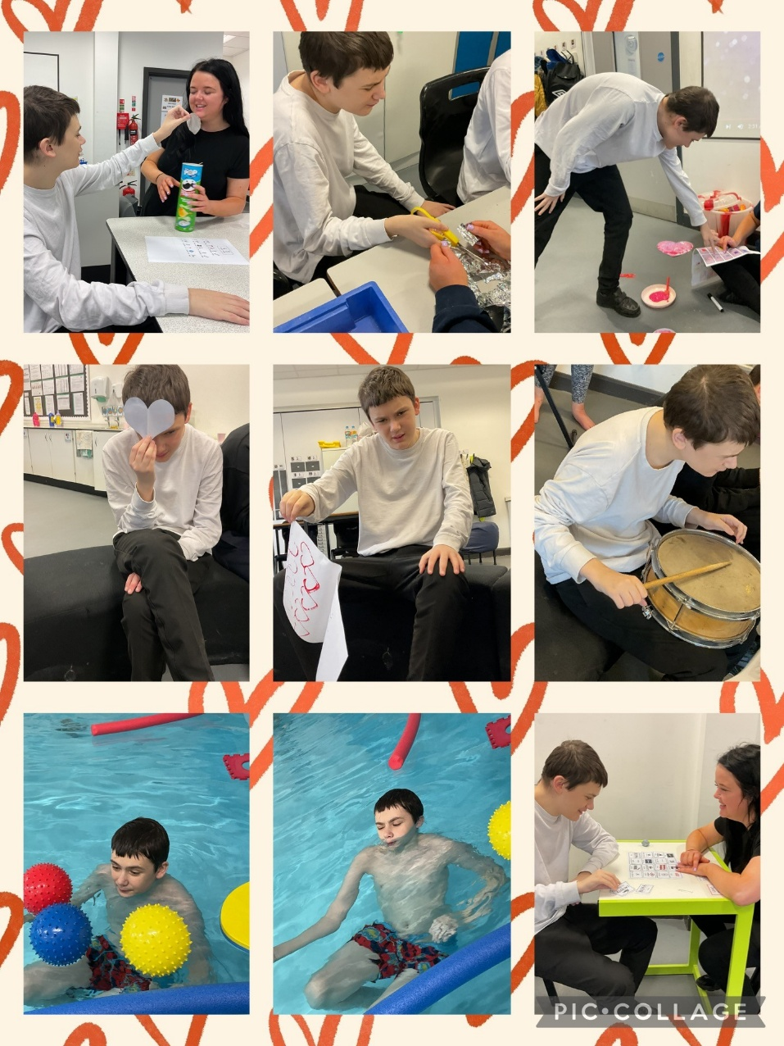

07/02/25
This week we have had lots of fun activities in A6.
English - we have started our new sensory story, Monkey Puzzle where we explored the different objects.
Maths - we have started our new topic of symmetry' and enjoyed making symmetrical butterflies from our sensory story using paint.
PSHE - we have continued to look at leaders who help us and have focused on police and how they keep us safe.
Understanding the world - we have followed on in our leaders topics and have focused on leaders of our country. We made some amazing crowns.
Food Technology - we looked at using a peeler and enjoyed peeling potatoes with adult help. Next week we are going to peel items of our choice.
In Life Skills, we have continued to tidy areas in the classroom to allow them to build knowledge on how to tidy at home.
In sensory play, we have linked leaders of our country so have enjoyed exploring sparkly glitter, shiny Pom poms and of course gem stones!
In Attention Autism, we have focused on Children's mental health week.
In Community Skills, we had a trip to Hydro and the shop.
We have also enjoyed regular soft play, sensory room, I muse, movement room and rebound therapy.
