A4 Class Blog 2025
11/07/25
A great week in A4.
In Math’s we have been working on adding and subtracting to get amounts.
In English we have been using colourful semantics to extend sentences.
In Community Skills we have been to oakwood shop.
We have been on a class trip this week to Saltwell park. Students enjoyed the park and a lovely treat from the ice cream van.
In Food technology we made chicken nuggets using the air fryer, and we made a side salad to accompany our nuggets, practicing our chopping skills.
We have had a very successful transition day! Welcoming 2 new students from another class into A4. We made cheese and ham toasties, we made playdough and followed instructions to create letter, make different sized snakes, making balls and stacking towers and using numicon to stamp numbers and telling staff what numbers we have made. We then printed photos of our faces and cut them in half. We then drew the other half of our faces to create our self-portraits. We then enjoyed interactive board games and celebrated Teddy bears picnic day by creating our own picnic scene
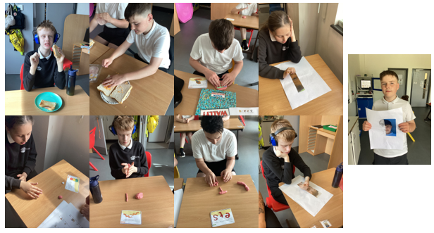
27/06/25
This week in A4 we have been working more on our story “the Hodgeheg” using colourful semantics to describe the scene and the characters.
In Maths we have been working on coin recognition, matching up coins and adding coins together to get amounts for certain items.
In Community Skills we have been on the bus to Fewster Square to get our treats, practicing road safety, money skills and social skills.
In Understanding the World, we have been looking at Public and Private places, looking at different situations and deciding if they are public and private.
In Food Technology this week we made chicken salad sandwiches, practicing chopping skills and spreading skills to create our chicken salad buns.
Students enjoyed their swimming lesson this week.
We have had a class discussion and completed some lovely colouring sheets on World Armed Forces Day.
We had a small transition of 1 hour in our new classrooms with our new teachers and friends. Students coped really well with this.
Certificates this week go to
RH for the fantastic feedback from his new class teachers.
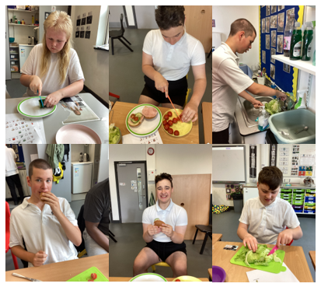
20/06/25
A lovely sunny week in A4 class.
We have worked hard on our new story The Hodgeheg by Dick King Smith. Students explored the setting, where the hedgehogs live and how they go to the park (as well as the hazards involved in crossing a busy road! Students have also worked hard on their phonics and are making lovely progress.
In Maths we looked at money, finding the coins for a set amount. Some students focused on matching coins to images of their value represented by dots.
In Food Technology, we cooked fish fingers in the air fryer and then put them into buns with mayo or BBQ sauce. Everyone enjoyed eating their sandwiches!
In Independent Living Skills, students practiced washing up, hanging up and folding clothes as well as sweeping and wiping.
Students also enjoyed Community Skills, we all walked to Oakwood shop in the sunshine and enjoyed eating our snacks when we got back to school. Students also did their first swimming lesson of the term as well as enjoyed their music therapy lesson with Chad.
We have also enjoyed the sensory rooms, dough disco, categorizing if someone is well or unwell, using the parachute and working on the new topic of Castles in creativity.
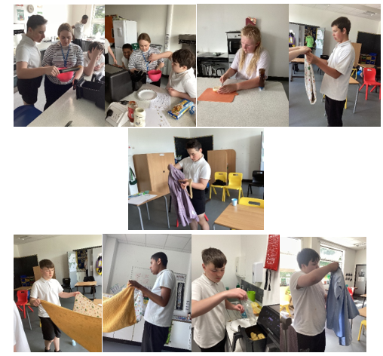
13/06/25
Another great week in A4.
In Maths we have been working on capacity, as a group we have worked through PowerPoints deciding if we think the containers are full, half full, empty or half empty. Students then followed written instructions to fill their containers.
We have been working out how many cups in takes to fill a jug, a bowl and a box and then deciding which one holds the most and which holds the least.
In English this week we have been reading the story “Winnie and Wilbur and the naughty knight”
Students then answered various questions about the story.
In Food Technology this week we made sausage sandwiches. Well done to the students for using the air fryer, doing their dishes and serving staff the most delicious sandwiches.
In Community Skills this week we got the public bus to Fewster Square and then got the bus back to school. Students followed all instructions given by staff.
This week we finally got to see our summer performance. It was the most amazing display of how fantastic our students are. We hope you all enjoyed it as much as we did.
Certificates this week go to
TO for his fantastic behaviour when out in the community, he showed excellent manners to the bus driver and the shop keeper and tolerated going in several different shops to accommodate his classmates.
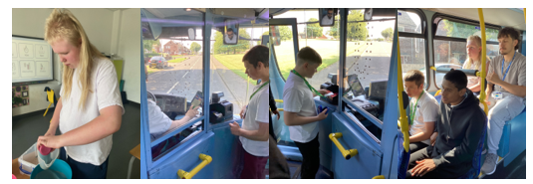

23/05/25
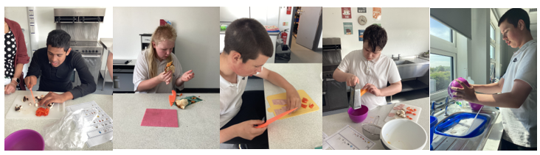
This week in A4 we have had a lovely week. In Math's we have been working on amounts of items and how much change we would need if we were to purchase them with various coins, using counters to support us. In English we have concluded our story "On Sudden Hill" We have sequenced the story and described each scene. We took part in the social story dressing as the characters and acting out the story. In Food Technology we made Pizza Wraps practicing various skills including chopping, slicing, blending and spreading. Students used an air fryer to cook their pizzas and enjoyed eating them. Well Done to students for washing and drying their own dishes. In Community Skills some of us went to Fewster Square practicing road safety, social skills as we joined another class this week, and our money skills exchanging coins for our snacks in the shop. Students got the public bus back to school and were all so very well behaved. In Understanding the World this week, we have been looking at Endangered species. Students have enjoyed sensory, iMuse and soft play sessions. Fitness Friday is always a huge success, and we love our rebound sessions with Mr Pallas, followed by some "Go Danny" workouts and gross motor skills outdoors. Certificates this week go to Jayden W for completing some fantastic pieces of work and his independent work in Maths this week. And also, to RH for his input in English lessons this week, answering all the questions he was asked and using some brilliant descriptive words to identify the characters feelings. Have a lovely week off and will see you all when you return to school on Monday 2nd June. A4 team Mrs Francisco, Mrs Smith, Miss Anderson, Mrs Moore and Mr Singre.

16/05/25
A brilliant week in A4!
In English we continued our work on the book On Sudden Hill. We enjoyed listening to the story, using props and enjoying biscuits and lemonade. We then used colourful semantics to describe an illustration from the book.
In Maths we weighed a variety of items, firstly using cubes to balance the scales and then counting the cubes to work out which item is the heaviest. We then used digital scales to weigh the items.
In Science we learnt about the water cycle and then carried out an experiment using a freezer bag to demonstrate what we have learnt.
In Food Technology we followed written instructions to prepare and make a strawberry and banana smoothie. Students are really improving in their peeling and chopping knife skills. Students then re-wrote the steps they took to make the smoothie.
We have also discussed things we can do in public and private and how that could make other people feel.
We also practised our mindfulness after discussing Mental Health Awareness Week and thinking about different techniques to support our mental wellbeing.
Students also enjoyed the sensory rooms, music therapy with Chad, Community Skills to Fewster Square, preparation for our summer performance, Fitness Friday and phonics.
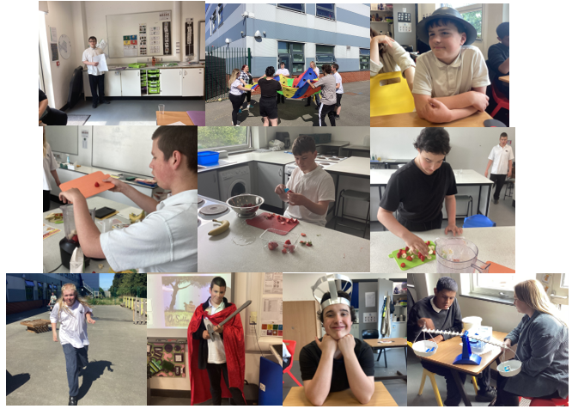
Well done A4!

09/05/25
This week in A4 we have been working on Mass, Volume and Density in Maths. We have been using weighing scales to determine which items are light, heavy, and what we can do to balance the scales.
In English we have been studying our story “On Sudden hill” dressing up as characters and constructing sentences using colourful semantics to describes the characters and their feelings. In Food technology this week we have repeated the same steps as last week to make another banoffee pie, with less staff prompting. A huge well done to ER and DA for their participation and interest and well done to the rest of the students working together to create the most beautiful pie.
In Community skills this week students walked down to Fewster Square, practicing their road safety skills and money skills. They were all so well behaved, and we got the public bus back to school. In understanding the world, we created steps that we need to take to plant a seed and talk through how the seed will grow. We then planted our own classroom sunflower, and each student followed instructions to gather their own equipment, and we have planted some cress seeds.
We have worked some more on personal hygiene and started our teeth brushing routine in school. We celebrated VE day listening to songs from the war and crafting our own spitfire planes. Students have used sensory room and iMuse as part of their regulation time.
We have been working on our summer performance with Miss Angus, and we are so excited to see the finished product and we can’t for you to come in and see it. We have been working hard to progress in our phonics this week. Students enjoyed our Fitness Friday session and rebound with Mr Pallas.
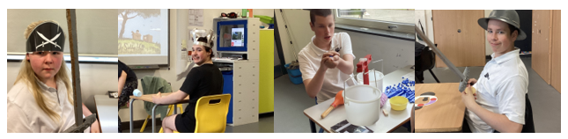
Class certificate this week goes to Dexter A for having an amazing week in school, he has completed lots of work and remained regulated all week. Well Done Dexter we are all so proud of you.

02/05/25
A4 have had a brilliant week.
We started our new story called On Sudden Hill. It’s a story about two boys who like to pretend play in cardboard boxes. We made astronaut helmets as a prop to support the story, as well as dressed up as different characters from the story.
In PSHE we discussed personal hygiene and which parts of our bodies we need to wash every day as well as discussing why it is important to wear clean clothes every day.
In Food Technology, we made a banoffee pie during which we practised our peeling, chopping and spreading. Most of us enjoyed eating it during our snack time.
We followed instructions to make play dough and used it to aid regulation during dough disco.
Our new topic is about the plant life cycle and nature. We spent some time outside, enjoying the sunshine, and completing a nature scavenger hunt. We talked about the different colours we find in nature.
We also accessed the sensory room, enjoyed time playing with the parachute for Fitness Friday as well as Community Skills and regulation walks.
Well done!
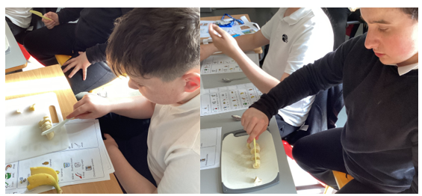

11/04/25
We have had a lovely half term in A4.

In English we worked on The Giraffe, The Pelly and Me, identifying the main characters and setting as well as discussing rhyming words.
In Maths, we worked on money, matching coins and notes as well as adding up coins in a purse.
In Understanding the World we focussed on Hinduism, thinking about where the religion originated, making our own mandalas, rangoli and diya lamps.
It was our half term to go swimming and all A4 enjoyed their time in the pool.
We also enjoyed accessing the new soft play, sensory room, movement room and iMuse.
In food tech we have been making foods in relation to Hinduism, we have made various curries, mango lassi, and Indian inspired sweets.
In Community Skills we have been visiting both Oakwood and Glynnfellis Premier Shop to purchase our treats, working hard on Money and Social skills.
We have enjoyed our Art and Sensory lessons with Miss Angus, colouring our own Madala pictures and temples.
Students are making excellent progress in their Phonics lessons.
We have enjoyed our music lessons with Chad.
Students have enjoyed sensory play.
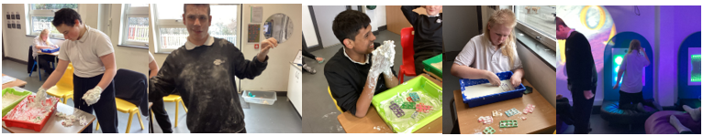
Have a lovely Easter Break everyone!

04/04/25
In English we read some more of The Giraffe, The Pelly and Me. We found out that the animals had set up a window cleaning company. We practised window cleaning in our independent living skills lesson and looked at rhyming words because the monkey likes to sing in rhymes.
In Maths we continued working on identifying the values of coins and adding up a set number of coins in our purses.
In Understanding the World, we read the story of the creation of the god Ganesh and then used coloured rice to create rangoli patterns.
In Food Technology we made our own Indian Peda sweets, made with double cream, powdered milk and sugar. Everyone enjoyed rolling them into a ball and then using the end of a spoon to imprint a star onto the top. They were a big hit with everyone in the class.
In creativity we painted Indian patterns.
We enjoyed Fitness Friday, stretching, jumping and dancing to a range of routines.
We have also enjoyed swimming, music therapy with Chad, rebound, regulating in the sensory room and soft play as well as being out in the sunshine and on Community Skills.
Well done A4.
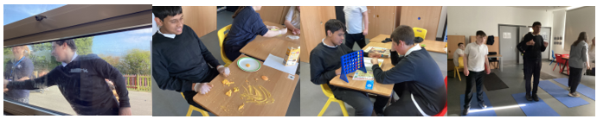
This week's certificate goes to TO for his excellent participation in Fitness Friday.

28/03/25
A4 have had a lovely week.
In English we continued reading The Giraffe, The Pelly and Me by Roald Dahl. We found out that they are window cleaners and they sing in rhymes. We looked at rhyming words and created our own rhymes about different animals.
In Maths we continued to match coins and values and calculating amounts in coins.
In Understanding the World, we learnt about the story of Rama and Sita, Hindu gods, and made our own salt-dough diya lamps. We also looked at the life cycle of a flowering plant before planting our own sunflower seeds.
All students took part in Lego club. One of our students experienced a sound bath which aims to aid regulation and sleep. We also accessed the sensory rooms, Rebound therapy, music therapy and the movement room. We also ventured out into the community as well as went swimming.
Certificate of the week goes to AC for his participation in the sound bath and accessing regulation activities.
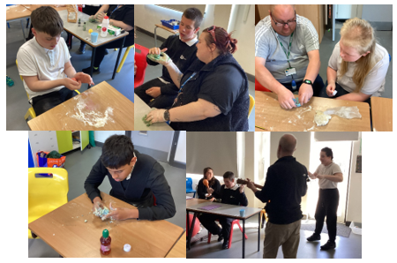
Well done A4.

21/03/25
A4 have had a lovely week.
In English we started reading The Giraffe, The Pelly and Me by Roald Dahl. We looked at the front cover and then predicted where the story may take place after reading the blurb. Students then thought about the characters and setting and used verbs and adjectives to describe them.
In Maths we started working on money, matching coins and values and then thinking about finding the equivalents using different coins.
In PSHE we talked about what makes a good friend and how we should treat other people like we wish to be treated.
In Creativity we created our own mandalas by painting by numbers.
We also accessed the sensory rooms, Rebound therapy, music therapy and the movement room. Some students took part in Lego club. One of our students experienced a sound bath which aims to aid regulation and sleep.
Certificate of the week goes to JW for his excellent prediction work about The Giraffe, the Pelly and Me by Roald Dahl.
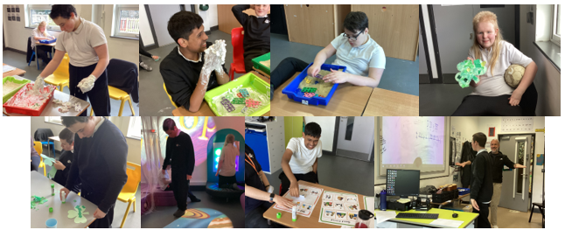
Well done A4.

14/03/25
A4 have had a busy week.
In English we learnt about Roald Dahl, the author of our new class books The Giraffe, the Pelly and Me. Students read about Dahl’s life and completed questions and colourful semantics.
In Math's we made number using numicon, finding the numicon in various trays of sensory items including, flour, rice, pasta, shaving foam and chia seed slime. We then read out the numbers then added 10. Well Done to DA who made large amounts and was able to add 10 and identify the number he had made.
In Community skills this week we went for a walk to Oakwood shop to purchase our treats.
Well Done to all students who participated in their swimming lessons this week managing 4 lengths each of each exercise instruction given by their instructor.
We participated in minion cosmic yoga, practicing our bridge pose, triangle pose and other various stretches.
We have made our own Madala design following on from our PowerPoint about Hinduism. These will proudly be displayed outside of A4 classroom.
We enjoyed our rebound session with Mr Pallas.
One of our students participated in a sound bath, this involves relaxing music therapy to aid sleeping, relaxation and regulation.
Students have worked very hard in their phonics lessons. Well done to ER for excellent work.
In food technology this week we have made a vegetable curry and rice, working on our chopping and measuring skills.
The new sensory room is now up and running, students enjoyed their sessions in this week.
With Miss Angus this week we have enjoyed our art and sensory lesson.
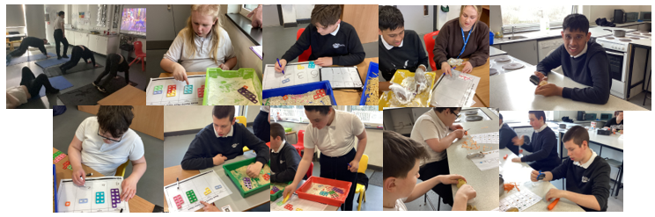
Class Certificate this week goes to ER for an amazing week in school, completing lots of work, remaining regulated and joining in lessons with the full group in class.

07/03/25
A4 class have had a busy and fun return to school after the holidays.
It was World Book Day on Thursday. We celebrated by looking at different characters in books, identifying them by their physical characteristics. We then chose a character to create on our potatoes. We had Thomas the Tank Engine, Mr Messy, Spiderman, Mike Lebowski from Monsters Inc. Everyone showed their creative side!
In Maths, through sensory play, we started creating and reading numbers past thousand. Everyone tried so hard, and students should be so proud of themselves.
We also accessed the brand-new sensory room, iMuse and soft play. Students thoroughly enjoyed exploring the new equipment and have asked to go back many times through the week!
We went to Glynfellis for Community Skills, and the students did really well on the long walk back up the hill to school. It was fun being able to explore a different shop and buying from a new shop assistant.
We also went to Washington Leisure Centre for swimming, had fun during Fitness Friday, worked hard on our phonics and engaged in sensory play.
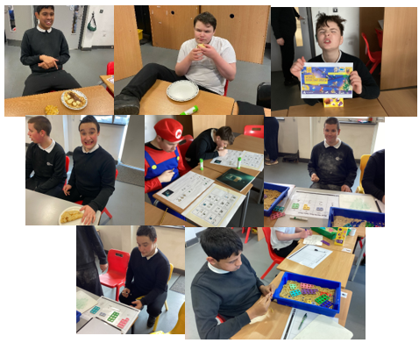
Well done A4 – another brilliant week!
31/01/25
There’s been lots going on in A4 class this week.
In English we continued reading our story The Barnabus Project and we thought about how the main characters were feeling during different scenes in the story. In Maths we did a 3D shape hunt before building different shapes with ice lolly sticks and playdoh and identifying how many faces, edges and vertices each shape has.
In Understanding the World, students celebrated Lunar New Year by trying a range of Chinese food and drinks, such as spring rolls, hoisin sauce, pocky sticks and aloe vera juice and discussing our preferences. Students also made noodles in our cooking lesson and snakes from paper plates to celebrate the year of the snake.
We discussed road safety and then put it into practice when going on our Community Skills visit.
Students have also accessed the sensory rooms, movement room and rebound therapy as well as music therapy.
Well done A4, another great week

Class certificate goes to J W for his contribution to our phonics session.

