A3 class blog 2024-25
04/07/25
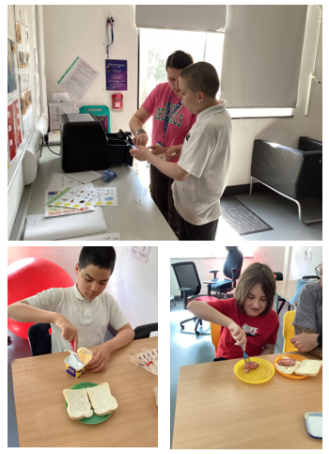
A3 have been very busy this week. They have enjoyed making their favourite sandwich on Thursday which was bacon! They looked at transport and made a hot air balloon sensory bag. Then identified different formms of transport, looking at ones that go in the sky and water. They have continued with the story Oi get off my train and practise functional maths skills. A3 had Mr Evans come to visit them on Thursday and they had lots of fun.

27/06/25
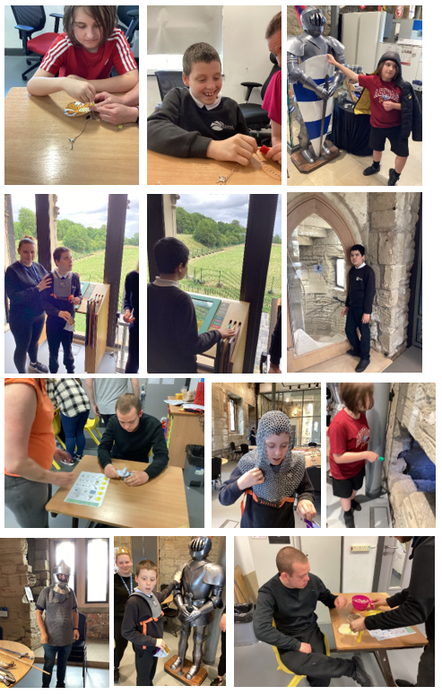
A3 have had a very busy week. They have been looking at castles. We looked at the different parts of the castle and what they mean and then identified shadows of castles and label the parts. We then went to visit Hylton Castle and Claire our Learning guide showed us all the different parts of the castle – we used torches to look in the bread ovens and up secret spiral staircases. We made our own crown and tried on parts of the armour – Mr Weites tried on the chain mail! We had lots of fun there as we looked at the ruined chapel and played archery outside. In food technology this week we have been making tuna sandwiches but no one liked the smell or taste of it except 2 pupils! We have been identifying different parts of our environment outside this week too. In maths we have been counting dragons and fish, some of us have calculated one more and some have sorted according to different colours. We have practised our fine motor skills and our thinking skills as we have found different keys to unlock the dragons and set them free. Lots of fun and more over the week. Well done A3!

20/06/25
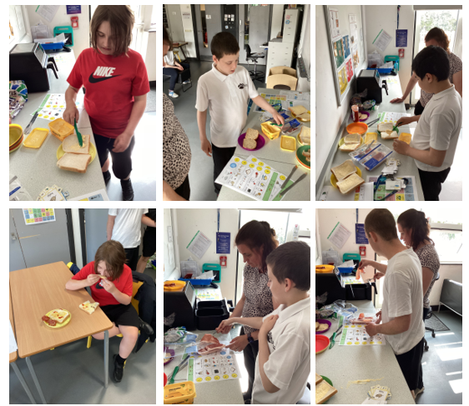
A3 class have enjoyed the sunshine this week, with lots of water play outside! We walked to the local shop where we purchased a treat of our choice and then enjoyed eating this in the nearby park before walking back to school. In food tech we looked at different meats and fish then made bacon sandwiches which went down a treat! In math’s we looked at measuring items and built a castle using 2D shapes. In history we explored castles even further and went on an exciting dragon hunt. In English we started a new sensory story, Oi, Get off our train!

13/06/25
A3 have had a lovely wee. We finished our sensory story Handa’s Surprise by using colourful semantics to describe and sequence the story, everyone did really well. Everyone enjoyed taking the bus to Fewster Square, going in to Greggs and walking to the park. Everyone had a great time. In food technology we enjoyed making sausage sandwiches, cooking them in an airfryer. We have been identifying items outside such as the road, crossing, lamppost and path. With Miss Angus we were looking at rivers and using materials to make our own river. On Wednesday we enjoyed sitting in the hall watching the performance. On Thursday some of us went to our new class for a visit, everyone did well.
Have a lovely weekend everyone.

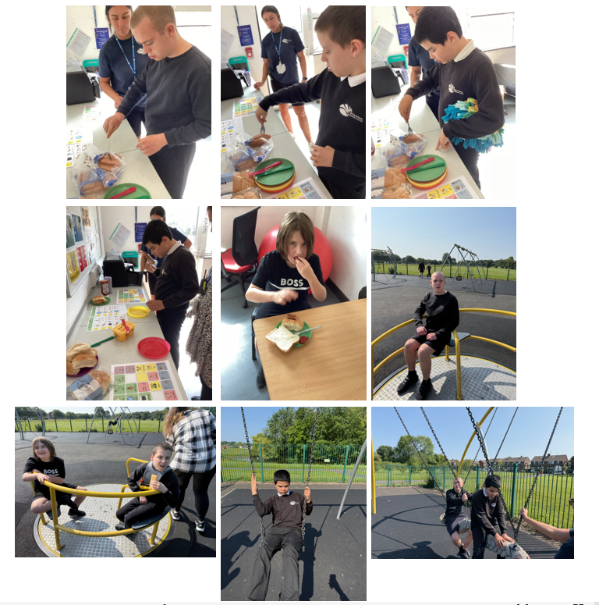

06/06/25
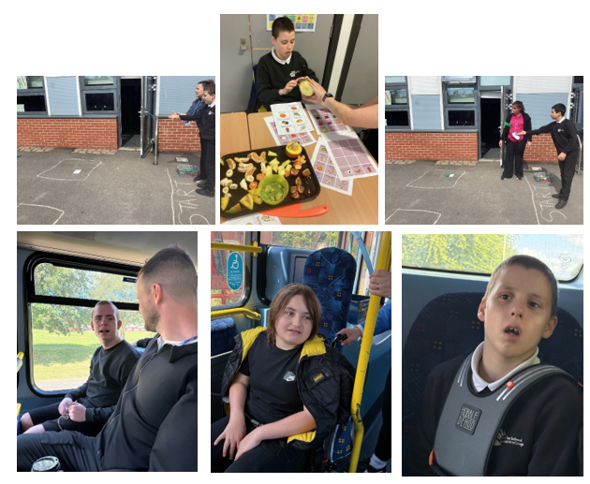
A3 have had a lovely first week back. Everyone enjoyed a walk to Greggs on Monday and chose something nice to eat. We then got on the public bus back to school. Apart of independent living skills we experience something new – massage to music and most of us accepted this new experience really well. We looked at all the fruits from Handa’s Surprise and identify each of them on our communication board. We then got to taste and feel them and used words to describe them such as the colour, size or description words. After that we decided which fruits we like and didn't like. Our food topic this term is fish and meat and this week we all enjoyed making fish finger sandwiches, using the air fryer and following the steps. In art with Miss Angus, we looked at different art materials to create rivers. In maths we have practised throwing bean bags a long and short distance and some of us measured the distance using our feet. In science we looked at manmade and natural objects, sorting them into different categories. We enjoyed looking at the Prode flag during bucket time.
23/05/25
A3 have had a lovely week. They have enjoyed peeling sweet potatoes and making fries in the air fryer, practising both chopping and peeling skills. In English, we have been looking at Handa's Surprise and we identified the animals and the fruit In the story. In maths we have continued to look at long and short items and some of us measured using cubes. In science, we have been sorting pictures of flower head, stems and leaves. The we used different parts of a flower and crested our own pictures of flowers. After that some of us labelled the different features. We then planted our own sunflower and watered them. We enjoyed going on the bus to Fewster Square and in to Greggs. Everyone told the assistant what they wanted and paid for the items with their money.
We have practised our fine motor skills by threading pasta and different items. We also used scissors to cut the cress that we planted the other week. With Miss Angus we used lots of sensory objects to re create the story of a bear hunt which we all enjoyed too.
16/05/25
A3 have had fantastic week. We have enjoyed Attention Autism as this was linked to the new sensory story Handa's Suprise. We looked at the different animals mentioned in the sensory story and explored the smells and tastes of the fruits from Handa’s Suprise. In PSHE we have continued to think about likes and dislikes. We practised our peeling and chopping skills again in food tech to make a fruit salad but using different again fruit this week. In independent living we took the public bus to Fewster Square and bought something from Greggs and sat and ate it in the square, then took the bus back to school. We enjoyed art with Miss Angus where we used different materials to make art for the summer performance. In maths we have looked at identifying big and small items.
09/05/25
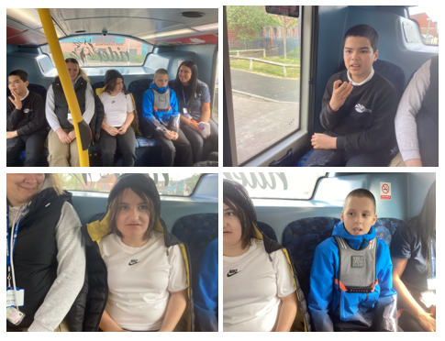
A3 have had a busy week back after bank holiday. We have been thinking about the sounds of each animal in the sensory story. We celebrated VE Day by listening to different sounds and identifying pictures and symbols. In PSHE we have continued to think about likes and dislikes and categorised animals and also a different set of fruit. We practised our peeling and chopping skills again to make a fruit salad but using different fruit this week. Before we made our fruit salad we looked at the different sizes and identified the big and small fruit. In independent living we have been to Fewster Square and bought something from Greggs and sat and ate it in the square. We all enjoyed getting on the public bus back to school. We enjoyed exploring different art materials with Miss Angus.

02/05/25
A3 have had a lovely first week back and settled into the term really well. They enjoyed a walk around Herrington Park and playing on the zip wire or swings topped off with a stop off at the shop to buy our favourite treats. They have been washing and cleaning animals they found in mud and completing some early writing and phonics activities. In food technology, they all followed instructions to make a fruit salad and as part of their PSHE they chose which fruits they liked and which they didn’t. They used colourful semantics to say how and where they made it. In sensory story time, we have started to look at The Busy Spider and we explored the different elements and then identified the different animals in the text. In maths we looked at the ‘Super worm’ story and then made big and small worms, some of us even measured them with blocks. Everyone has enjoyed the many times we have had waterplay as some of us love it and it helps us stay cool in the hot weather. We have all been brushing our teeth this week. Lots of personal targets were achieved including following instructions to boil a kettle.
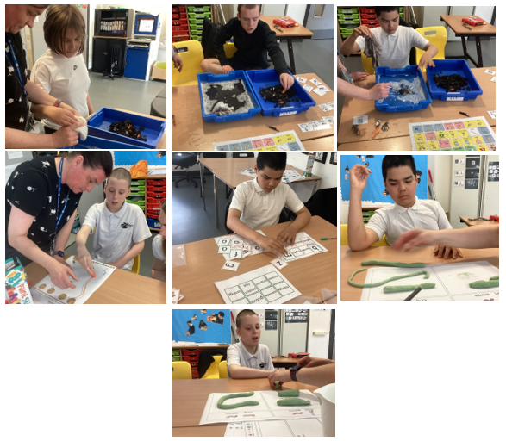
Some of us are looking forward to being back at hydro and some of us the swimming pool. We are all going to attempt the mini marathon on Friday afternoon!

11/04/25
Everyone has achieved lots of things this half term. Personal targets that cover independent living and PSHE. Extending our communication throughout the day including the dinner hall. Some pupils can go up and get their own dinner from the hatch now. Some of us have been practising our waiting skills which is another important goal. Others have practised brushing their teeth and also washing our hair. We have also exchanged money for items in a role play situation in school and again in the shop. We have been able to access different parks by either walking there or taking a taxi and went out as a whole class the past few weeks. It has been great working as a whole class on all these targets especially seeing how emotionally regulated, we have been.
On top of all this we have learnt loads about stories, money, Indian culture, different traditional dishes, friendships, Mexican culture, looking after ourselves, halving, Attention Autism, peeling different things, Leaders including the late Queen and our King which meant we practised pouring tea from a tea pot and I am sure there were other highlights.
A big thank you to all families for your support this term.
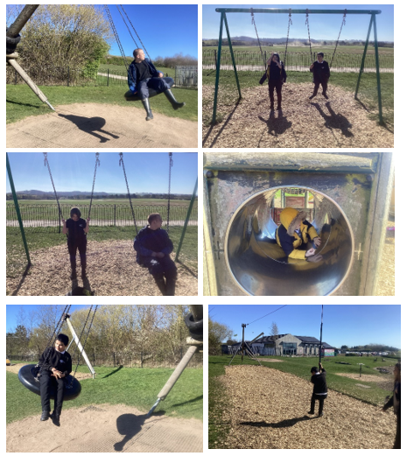
Have a good Easter break!

04/04/25
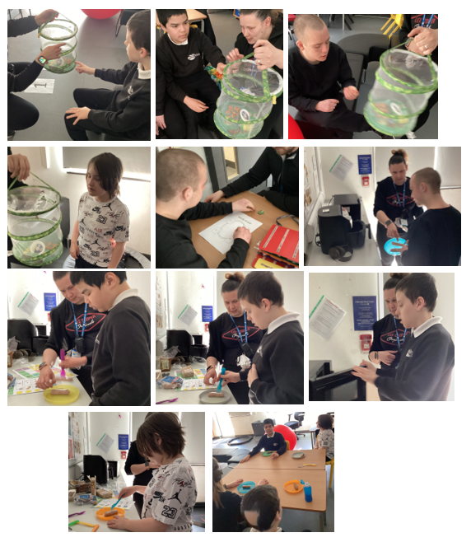
This week pupils enjoyed a walk to the park and the shop. In food technology everyone enjoyed making sausages and chips and eating them. In art we looked at primary and secondary colours and practised mixing them. In maths we have counted pennies and practised paying for different items. We looked at friendship qualities and played friendship bingo. We have discussed when we need to ask for help and when we don't need help and sorted symbols. We have looked at where the characters were and said where the gingerbread lived. In poetry we looked at the 5 little ducks and counted them in and out the pond. For careers, we have enjoyed looking at the job of a builder. We also enjoyed looking at the butterflies before they were released and completed work about the life cycle.

28/03/25
This week pupils have been describing a character from Mr Wolf’s Pancakes, we could say if he was a boy or girl and if he liked to sleep or not – can you guess who it was?! In maths we continued to look at money and chose the correct coin to trace and we all paid with our money for items at the shop. In understanding the world, we explored sensory items related to a train journey through India and looked at spices and coloured saris and bangles. We then cooked curry and rice in the microwave during food technology and tasted them and naan, poppadom's and mango chutney. We have revisited what we can put in our mouth and what we can’t and then looked at times that we can ask for help and when we could do things ourselves. The career focus, this week, was ‘musician’ and we all enjoyed making home-made shakers. We have enjoyed our poem - ‘the farmer plants the seed.’ In wellbeing we have been taking turns painting a flower. In science we have also been looking at the butterfly cycle again.
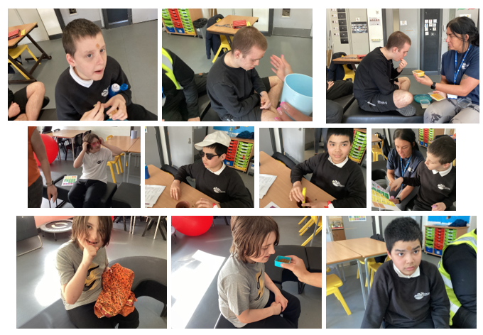
21/03/25
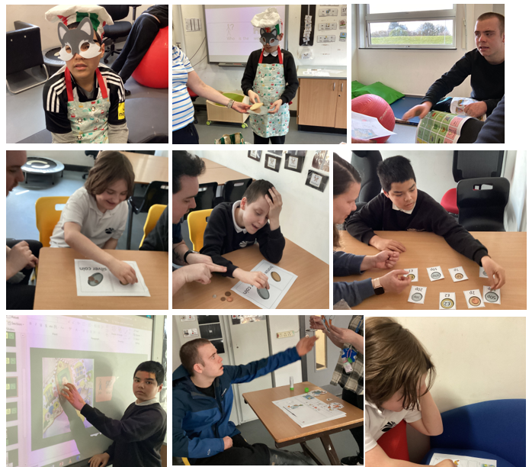
This week pupils have been looking at the story Mr Wolf’s pancakes. We have explored different parts, identified the wolf and Chicken Licken and some of us have ordered the size of chickens. We have been learning about butterfly life cycle and looking at our school caterpillars that have started the chrysalis process. In art we looked at the Lotus flower. In food technology we made our own pizzas and cooked them in the air fryer. In independent living we were sorting things we can and can’t put in our mouth. We have also been looking at the next career which was hairdressing, and we practised brushing hair. The next poem we have explored is ‘I hear thunder’. In maths we have continued to look at money and we sorted coins into bronze and silver and also looked at the different denominations.

14/03/25
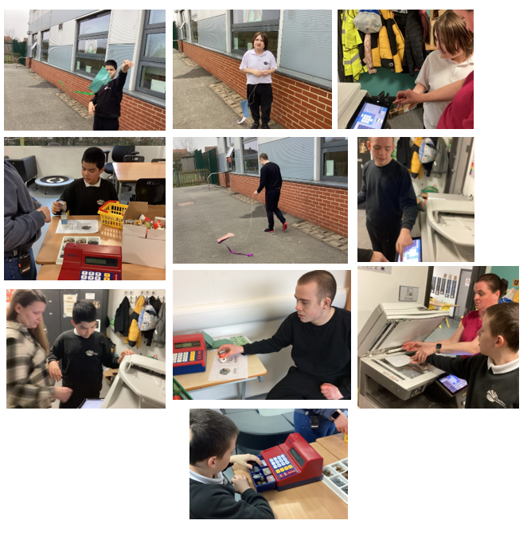
This week pupils have been full of busy as usual. In maths we practised halfling and quartering different items. The we moved on to money and everyone enjoyed working with the till and looking at the money and items to buy. In English we finished our story about the shark in the park by following instructions to make a kite and then we went outside to fly our kite. With Miss Angus, in art, we continued to look at colours to do with Hinduism. For food technology we finished off our Leaders topic by making Mexican wraps, everyone followed the instructions and a lot of us ate them! We have also been showing how well we follow our class rules: listening to staff, sitting with the group, taking the register and taking items back to other classes. We have also been set a problem by our teachers; they gave us jigsaw puzzles to complete but had taken pieces away and we had to use our communication skills to ask for the missing pieces; some of us were first looking for the pieces on the floor in case we had dropped them! We have enjoyed our new sensory and soft play rooms this week too.

07/03/25
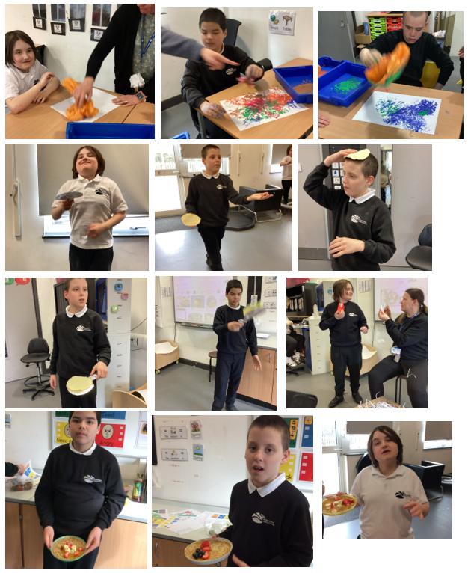
This week pupils have enjoyed being back at school. We have been full of busy as usual. In art we looked at the Hindu temple and decorated it. We have continued with our story Shark in the park and found other objects and we could all say who the different characters were in the story. We have started looking at poetry and started this week looking at 5 speckled frogs and enjoyed moving the frogs into the pool. We have started looking at different careers and this week we had a box full of shredded paper with different admin/office objects and we were looking for them and matching them to labels. For pancake day we were practising tossing pancakes, walking with them on our heads and hands and blowing them off our hands! In food technology we used a microwave to heat up our pancake and then cut up different fruit to put on top. In understanding the world, we continued looking at leaders and looked at the art leader Frida Kahlo. We used plastic bags to paint the same backgrounds and then got dressed up and had photos taken. We also enjoyed decorating potatoes as characters for world book day with a well-deserved trip to the shop.

21/02/25
This week in food technology, we made ham sandwiches and some of us enjoyed eating them. In maths we looked at sharing amounts between two people. In understand the world we learnt a bit more about Mandela and had a ‘kind’ token, we used this to hand to our friends some sweets! In our sensory story we were identifying different items in the story. In music we enjoyed using the keyboard again.
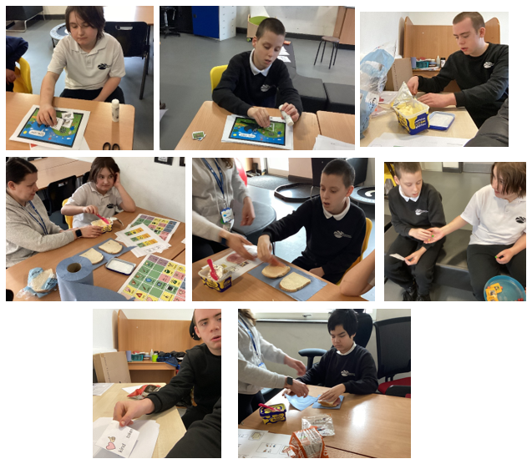
Have a lovely weekend and half term off!

14/02/25
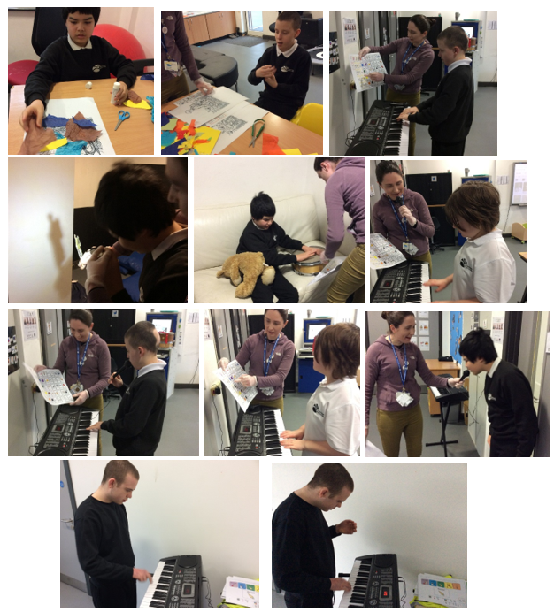
This week in food technology , we peeled parsnips and roasted them with carrots in the air fryer. Then we had them with Yorkshire puddings and gravy. We looked at symmetry when we made Valentines cards. We were looking at different characters in our sensory story ‘Shark in the park’ and trying to always spot the shark. In understanding the world, we have started to look at a different leader. We read Hamda's surprise as it is from the same country Africa as Nelson Mandela, we have learnt that he is a man and wanted peace. With Miss Angus, we enjoyed playing the keyboard and singing into the microphone.

07/02/25
This week in food technology, we peeled cucumbers and made cucumber sandwiches. We finished off our English leaders topic by making crowns and then we had a tea party and ate our cucumber sandwiches and practised pouring tea from a teapot – very British! We finished reading our story and made butterfly prints. We have started our next story ‘Shark in the park’ and explored the different elements. In maths we have looked at the same patterns on each side of a butterfly and been matching the same objects as they were cut along the symmetry line.
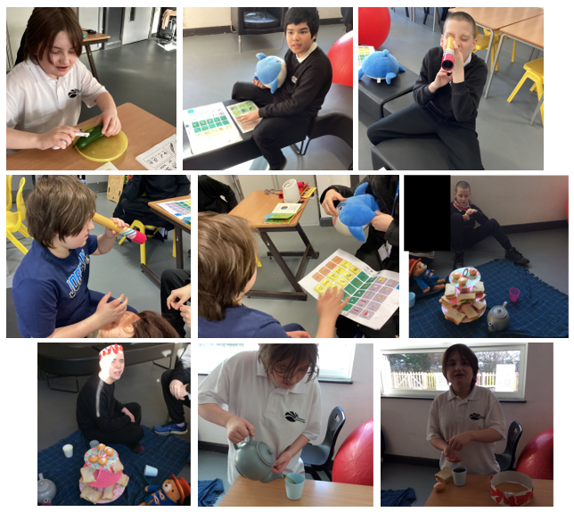

31/01/25
In maths we have been making shape pictures and then identifying rectangle and cylinder while we made our Chinese lantern to celebrate Lunar new year. We watched our story Monkey puzzle on YouTube. In understanding the world, we peeled boiled eggs and made egg and cress sandwiches with our home-grown cress! We have been making our own crown and decorating it with different jewels. In music we were playing the drum and we all enjoyed it. In food technology we made fruit salad. Everyone tried hard to peel their apple but could manage peeling banana and oranges. They all cut the fruit themselves, and some ate it all up. Two boys enjoyed hydro and the other three pupils are pleased the swimming pool is fixed!
Have a lovely weekend.
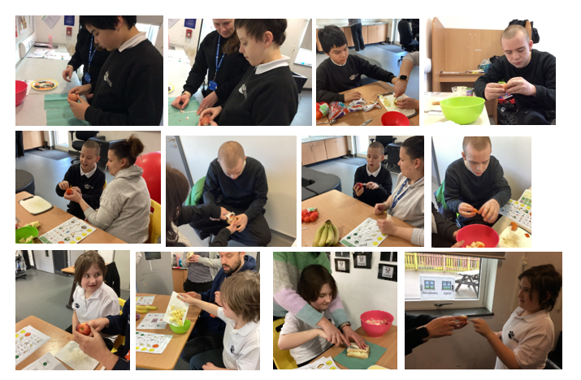
24/01/25
In maths we have continued to look at shapes and made pictures with them. In food technology we have practised peeling, this time apples and we made an apple crumble in the air fryer. Our sensory story is Monkey Puzzle, and we have been listening to the sounds of each animal and played sound bingo. We have also been describing the animals. In understanding the world, we have looked at the leader Queen Elizabeth II and learnt she lived in a palace and a castle and then we looked at other London landmarks. We then watched Paddington Bear and the Queen ‘video clip’ from the Jubilee concert and learnt they both like marmalade sandwiches! We then followed instructions to make our own marmalade sandwich.
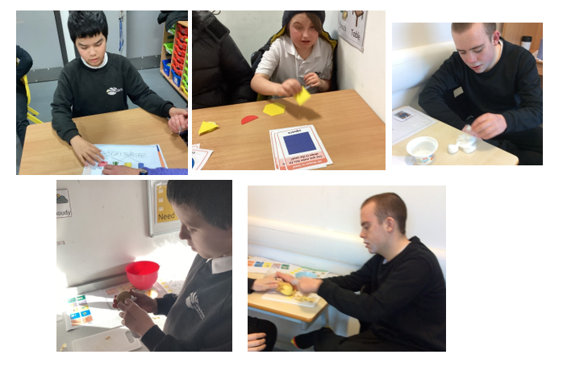

17/01/25
In maths we have started to look at shapes and categorizing them and consolidating what we already know. In food technology we have practised peeling potatoes and then making crisps in the airfryer. We then looked at making choices and tasted the crisps and shop crisps and said which we liked. We have also chosen which picture we wanted to make into a puzzle. Our sensory story is Monkey Puzzle and we explored all the elements and then looked at adult and baby animals. In art we looked at female leaders and we looked at shiny materials to make a rocket. In understanding the world, we looked at the leader Kind Charles III and made a collage. We learnt that the King likes plants and looking after the world and we planted cress seeds.

