A2 blogs 2024-25
Teacher: Miss Short
TA’s : Miss Wilson. Miss Rumming, Mr Cullerton, Mrs Hidmarsh

04/07/25
We have had a great week in A2!

In English, we have been continuing looking at Whatever Next for our sensory story and then did some comprehension work. In maths, we continued looking at heavy and light and measured weight using scales and various objects.

In food technology, we made some fish finger sandwiches, continuing our meat and fish preparation target and using the air fryer.

We had a visit to Saltwell Park on Thursday, and our students really enjoyed themselves. We played in the park, visited pets' corner and even got some delicious ice creams and sat in the sunshine.

We had our sports day this week as well and all students did brilliantly and took part in many activities. Well done to all of the pupils at Hill Top for fantastic participation!
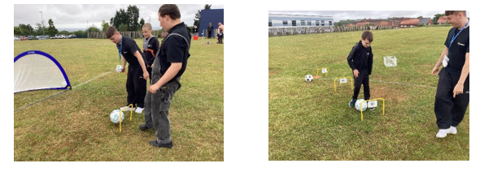

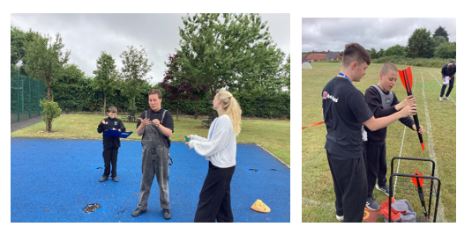
27/06/25
This week in A2, we have had another great week. In maths we continued looking at heavy and light using various materials and scales.

We made chicken nuggets again in food technology, using the air fryer to cook them. We particularly enjoyed dipping the chicken in the egg and the breadcrumbs!

We had a visit to Riverside Park in Chester-Le-Street and took a walk around and then had lots of fun in the park. We had ice creams or lollies and ate our lunch while we were there. All the pupils had a fantastic time, as well as the staff!
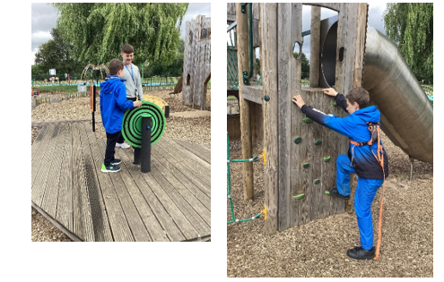

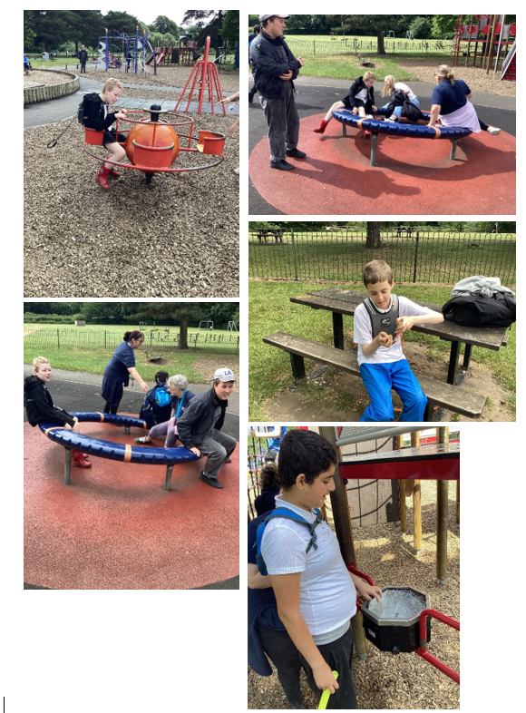20/06/25
This week in A2, we visited the Tim Lamb Centre and our pupils had such a fantastic day! We had time trampoling, visited the sensory room, played in the soft play and had some outdoor fun.
In maths, we explored the concept of heavy and light, using measuring cups and mechanical scales. We also had community skills and visited our local shop and we are improving with our money skills.
As part of our castles topic, we have done some artwork, decorating pictures of kings and queens and castles and practicing our cutting and sticking skills. We also learned some new makaton signs related to our topic. We specifically looked at Alnwick Castle.

13/06/25
This week in A2, we really enjoyed watching our school performance that we worked so hard on! We hope the parents and carers that came along enjoyed it too. Well done to the whole school, and a special thanks to Miss Angus, who as always, did an amazing job producing it.

We also started our new sensory story, "Whatever next". We have really been enjoying this and following this, in English we have been using colourful semantics to make sentences.

In food technology, we made chicken nuggets and followed the instructions well and they were delicious. Using our cracking egg skills and using the air fryer to cook them, one of our students was very keen to serve them to his peers.

This week, we had transitions on Thursday so our pupils could get used to new classrooms, teachers and classmates and we did really well with it. We have also enjoyed some time in the sun with the parachute and outdoor play with the lego.
Thanks to everyone that came along to watch our performance, have a great weekend.

06/06/25
This week in A2, we have been settling back into school after our half term week.
We made beef sandwiches in food technology, practicing our knife skills further.
In maths, we explored weight and looked at the concept of heavy and light. We sorted items into heavy and light and then used scales to weigh the items.

We started our story, "Whatever next" and did some work identifying who the characters are and also describing them.

We have had lots of sensory sessions and we enjoyed our weekly visit to the shop for community skills. Have a great weekend everyone!
23/05/25
This half term in PHSE we have been looking at Careers linked to growing food so we have gone to help out on the farm for the day at Bill Quay Farm! We have been very impressed with all our pupils helping feed and look after the animals. We also enjoyed exploring the park and the Gruffalo trail.
Well done A2!
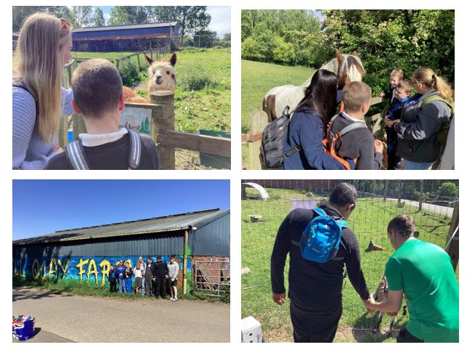

16/05/25
This week in A2, we continued our sensory story, Handa's surprise. We completed some colourful semantics activities and we will shortly move on to story sequencing.

In maths, we continued looking at capacity and measuring sand using jugs. we continued learning about the concepts of full and empty as well.

In food technology we made some cheese sandwiches, continuing with our knife skills. The students practiced spreading the butter and also cutting the sandwich.

We also did some fruit tasting this week and our students did very well trying out different fruits. We then completed an activity afterwards, sorting which fruits we liked and disliked.

09/05/25
In A2 this week, we have been enjoying the story "Little Red Hen" this week and also our sensory story, "Handa's surprise". We did some work on identifying characters from the story using colourful semantics. In maths, we have been learning about capacity and focusing on the vocabulary of full and empty. We used sand trays and buckets to explore this.

We have been incorporating tooth brushing into our morning routine too and everyone has made a great effort to do this, taking it in their stride as an addition to our usual daily routine.

We enjoyed a trip to the shop as part of community skills. In food technology we did more practice on our knife skills, making toast and crumpets, using the communication board to choose. We have also been making some VE day art as well as sensory play.
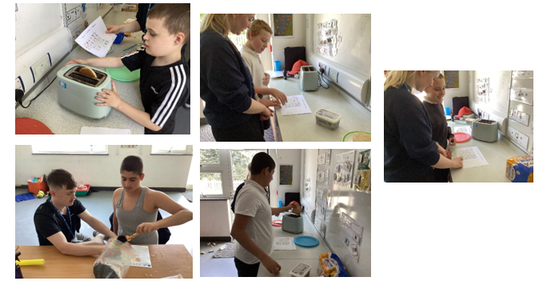
02/05/25
A2 have had a great first week back after the Easter Holidays. Our topic this half term is 'Growing', we have started growing cress in Understanding the World, and have been looking at Farmers growing food in PHSE Careers lessons. We have also enjoyed our new sensory story of Handa's Suprise, pupils have been engaging in group story telling as well as identifying who is in the story and describing characters. In food technology we have been practiced our knife skills making toast. In maths we have been working on capacity, we have been making sandcastles, filling and emptying our buckets. Great first week back everyone!
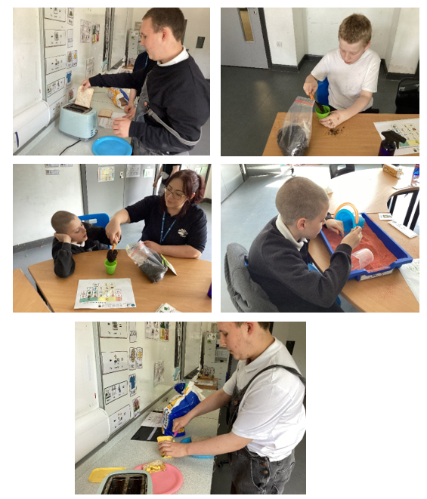

04/04/25
This week in A2, we have continued with our new sensory story, Mr. Wolf's pancakes and for our sensory poem, we did 5 little speckled frogs.

We have painted some easter eggs and did some other Easter crafts. In maths, we continued working with money and identifying coins, and then put this into practice going to the local shop. In food technology this week, we made some tasty naan breads.

We also did some work on Autism awareness, for world autism awareness week.

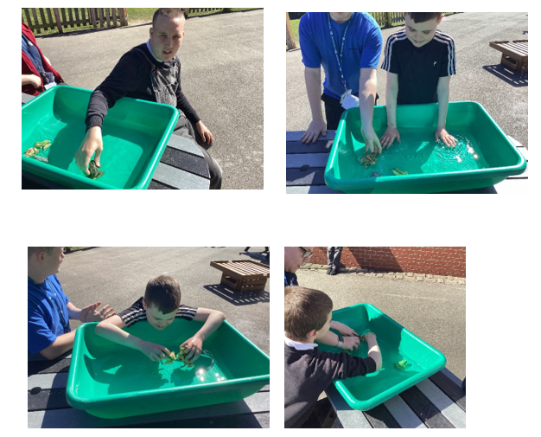
We are continuing to look at careers and this week and we have looked at gardening, we planted some sunflower seeds and made some edible soil!

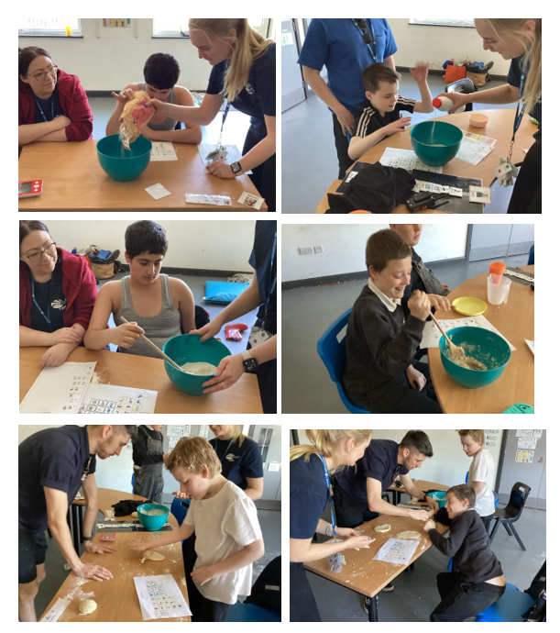
28/03/25
This week in A2, we started a new sensory story, Mr Wolf's pancakes! In poetry, we looked at "5 little ducks" and had some lovely fun outside with the ducks in the water and practicing our counting skills.

In food technology, we practiced using the microwave again to make some yummy chips and then enjoyed them for snack.

In maths, we continued looking at money and role playing buying things from the shop, before going to the local shop for community skills again.

We enjoyed some team games using the parachute and had a lovely time! We finished off the week by making Mother’s Day cards and planting some sunflowers to take home.
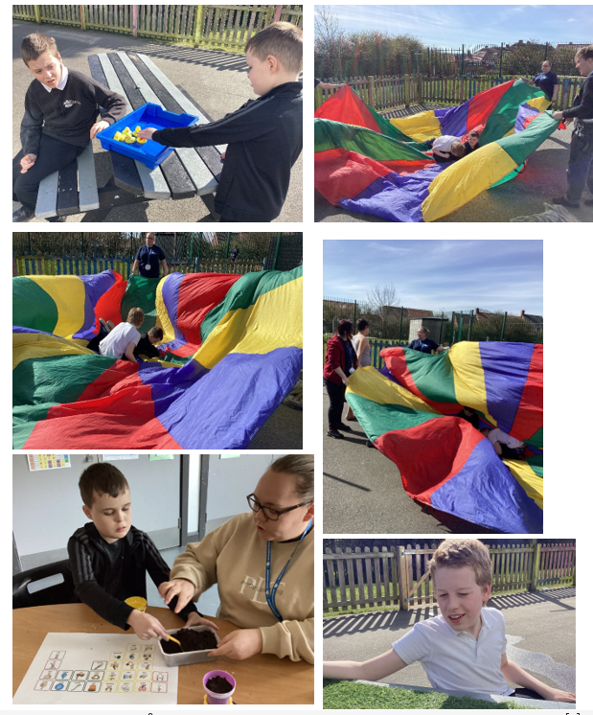

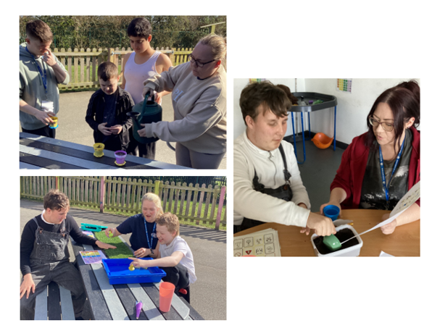21/03/25
This week in A2 we have explored our topic of Hinduism by making our very own Rangoli patterns with rice, pupils worked hard. Pupils in A2 have continued their sensory story, 'The very busy spider' where pupils have explored sensory objects based on the story and used communication boards to communicate what is happening or who is in the story. This week, our poem was based on a growing flower where pupils were able to create their own flower with sensory objects. In Maths, we have been continuing looking at money. They have been identifying coins and notes. Some pupils have been matching the correct coins to amounts. We continued our community skills visits to the local shop where pupils were able to exchange money and practice some road safety. In Food Tech this week, A2 have been practicing using the microwave to make some microwave chips. Some pupils enjoyed tasing them too. Some pupils have continued to enjoy their time at hydro and others at swimming practicing their skills.
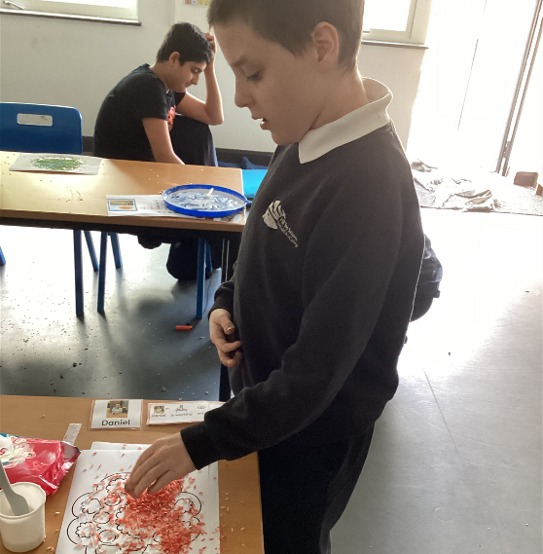
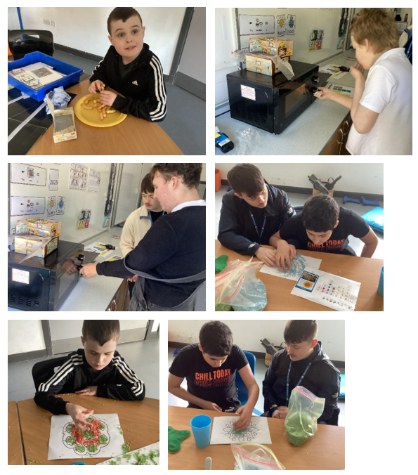

14/03/25
This week in A2 we have continued with our sensory story, "The very busy spider" and we repeated our poem from last week, "I hear thunder", using the musical instruments to copy the sound of thunder. We also designed our own umbrellas. We also looked at identifying characters from our story, "Mr. Wolf's pancakes".
In independent living skills, we looked at how to ask for help and we had a visit to the local shop for community skills. In maths, we have continued looking at money and identifying coins.
For well-being we have worked on what are good choices and bad choices to make and some of us also took part in a sound bath session, practicing relaxation techniques.
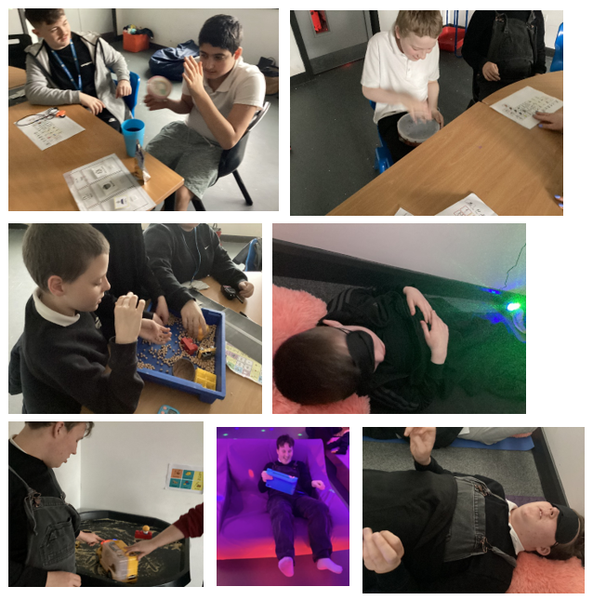

07/03/25
What a great first week back after half-term! We have absolutely loved our new and improved sensory room!

In our understanding the world lesson, we looked at Hinduism. We had a lovely sensory session, tasting Indian food and smelling spices and exploring instruments. For poetry we looked at "I hear thunder" and enjoyed sitting together with the props and we also started our new sensory story, "The Very Busy Spider".

On pancake day, we had food technology and we all designed our own pancake, choosing toppings from the communication board and we then decorated them.

In maths, we looked at money and how to buy items from a shop. With our role play shop equipment, we brought a basket and practiced buying things and counting the money to pay for them. Following on from this, in community skills, we went to the local shop and everyone chose one item to buy. Everyone enjoyed eating their yummy snacks when we got back from the shop. Great job everyone!

For World Book Day, we had lots of creative fun, decorating potatoes for our competition! Well done everybody for a great week

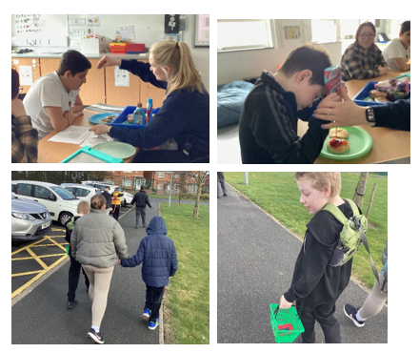

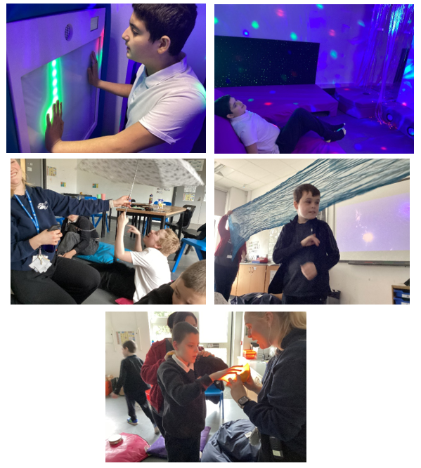

21/02/25
This half term in A2, we have been very busy! For English we enjoyed our sensory stories, Monkey Puzzle and Shark in the Park. We did work on identifying characters in the story, and some of us worked on describing the characters and anticipating what would come next in the story. In maths, we have done lots of work on shapes, patterns and symmetry. We made some butterfly pictures and explored using mirrors for symmetry.

Our topic this half term has been leaders. We learned first about leaders in our school. We then looked at leaders in their field, including Frida Kahlo, David Attenborough and Neil Armstrong. We did some lovely Frida Kahlo inspired artwork, made some space themed sensory bottles.
We have enjoyed our food technology sessions, practicing peeling and making fruit salads and banana splits. We also made cookies and some themed food technology lessons based around our topics, including snake breadsticks for Chinese New Year and tacos when we were learning about Frida Kahlo.

In independent living, we practiced teeth brushing and looked at what items we might find in a first aid kit, and who can help us in the community. As always, we did very well in our Attention Autism sessions and enjoyed swimming and hydro sessions too!
14/02/25
In maths this week, we continued learning about symmetry and explored using mirrors, looking at our reflections using props, and experimenting with infinity lights.
In English, we did some more work on identifying and describing characters from our sensory story, "shark in the park".
In sensory play, we enjoyed making some playdough and doing playdough disco. We made some Valentines Day cookies in food technology. We did so well following visual instructions.
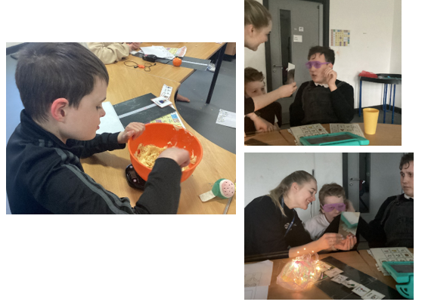
With Miss Angus, we took turns playing the keyboard and using the microphone, we had lots of fun! In creativity, we made some collage pictures and we have also made some Valentine's pictures to take home.
We have had a great week!

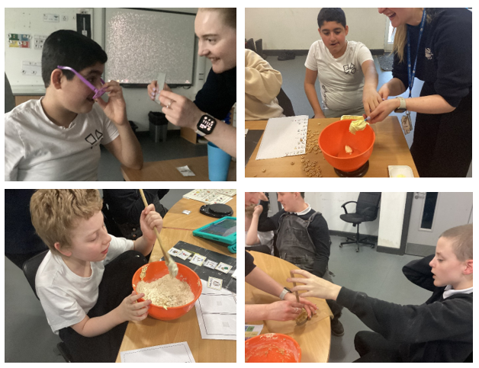
07/02/25
This week in A2, we have started our new sensory story, "shark in the park". We had lots of fun!

In maths, we continued with symmetry and made some butterfly pictures.

As we continue to look at leaders this term, this week we looked at Frida Kahlo. We made some fantastic artwork based on Frida Kahlo's techniques. In food technology, we made some Mexican tacos to tie in with our Frida Kahlo theme.

In creativity with Miss Angus, we learned about about Boadicea and enjoyed some dressing up in Roman outfits and decorated some shields.

We also had a lovely session in soft play with the instruments, follow the leader style, copying the beat.
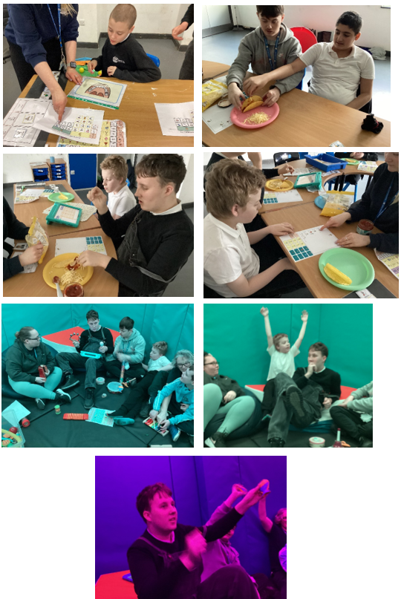

31/01/25
This week in A2, we have been looking at Chinese New Year as part of Understanding the World, and enjoyed a sensory story, Lunar New Year. For attention autism, we did a special Holocaust memorial session. We have enjoyed lots of artwork this week based on our topics.
In food technology have made some breadstick snakes! They were very tasty and it helped us practice our chopping skills.
In Maths, we have been looking at symmetry, and made beautiful butterflies. With Miss Angus, we looked at Georgian times and made and decorated our own fans.
We enjoyed doing some teamwork with the parachute, taking turns holding it and going under it, lots of fun!
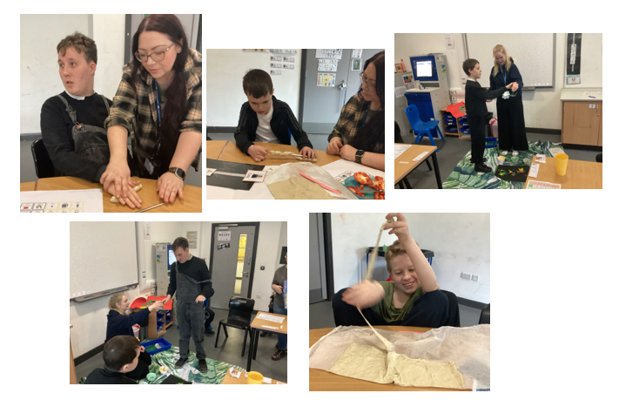

24/01/25
This week in A2, we have been looking at Chinese New Year and in attention autism, we have enjoyed making dragon and firework art. In food technology we made a lovely banana split again, working more on our cutting skills. We have been learning about leaders in their field, and with Miss Angus we learned about Greta Thunberg and made some lovely collages of planet Earth.

In English, we have also been continuing with our sensory story, Monkey Puzzle and we have worked on identifying feelings. using characters from the book. In maths, we are looking at pattern recognition, and some of us are creating our own patterns. Have a great weekend everyone!
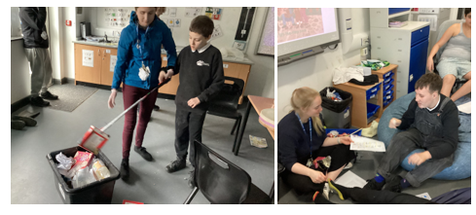

10/01/25
This week in A2 we did very well settling back in after our Christmas break. We have started our new sensory story, “Monkey Puzzle” and we are enjoying it very much. In our understanding the world lesson, we watched part of a David Attenborough documentary and then completed an activity identifying which animals live in different habitats.
We have also been looking at “leaders in school” as part of our topic. In maths, we have continued looking at 3D shapes and pattern recognition. We have enjoyed some collage artwork with Miss Angus, and in food technology, we’ve also made a yummy fruit salad, learning how to peel and chop fruit…delicious! Have a great weekend everyone.
