2024-25 A1 Blogs
Teachers: Miss Dobson, Miss Jackson
Support staff: Miss Morrow. Mr Hepton, Mr Dix

11/07/25
A1 have had another busy week! We have continued our sensory story on Whatever next, the pupils have sequenced the story and completed a book review. In Math’s we have continued with direction and followed directions to find certain items on a map. In food technology we practiced making chicken nuggets again to check what we could remember when making them. In well-being we have continued to look at changes in the body. We have enjoyed going out on community skills to the local shop and going out swimming. We have enjoyed our Attention Autism sessions on rockets! We also enjoyed our transition day on Thursday going to our new classrooms! We are looking forward to next week for our trips!
04/07/25
This week in A1 the pupils have enjoyed their sensory story whatever next, the pupils have worked on making sentences with colourful semantics and then the pupils decided what they would pack in their suitcase if they went to space! In Maths, pupils have continued to learn about direction and have followed direction on a match to get some prizes!
In Food technology pupils have enjoyed making chicken nuggets from scratch!
In well-being pupils have looked at body changes when they get older. The pupils tried really hard on their sports day! Pupils took part in all of the activities and were amazing! Pupils have enjoyed some sensory lay making castles and making cakes for a king or queen! Pupils have enjoyed their swimming sessions and time in the sensory room.

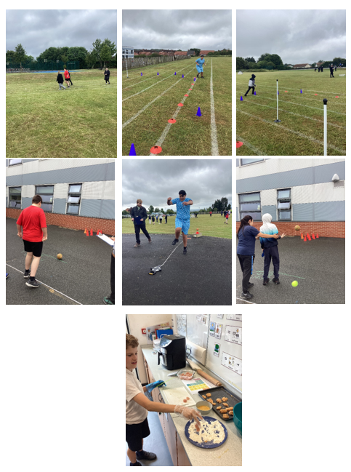

27/06/25

A1 have had another busy week! This week in English we have continued to enjoy our sensory story Whatever Next. We have then enjoyed describing a setting in the story and then commenting on pictures in the story using colourful semantics. In Maths we have been working on positional language and direction, looking at left and right. In Food technology we have looked at what we have made over the year and what skills we have learned. In Understanding the world, we have continued to look at castles and have labelled parts of a castle. We have enjoyed a trip to the local shop and our swimming sessions. We have enjoyed our time in the sensory room and iMuse.
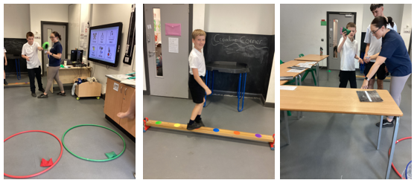

20/06/25
This week A1 have had a busy week. We have enjoyed our sensory story Whatever next and we have looked at the different things and characters in our story and have described them. In Maths we have been working on positional language and have completed some fun activities with bean bags and balance beams to practice the positions. In understanding the world, we have continued to look at castles. We have continued working on our phonics knowledge and completing some phonics activities. The favourite part of A1’s week was going on a trip to The Tim Lamb centre! Everyone had the best time and behaved really well! We have also enjoyed creativity and sensory with Miss Angus!

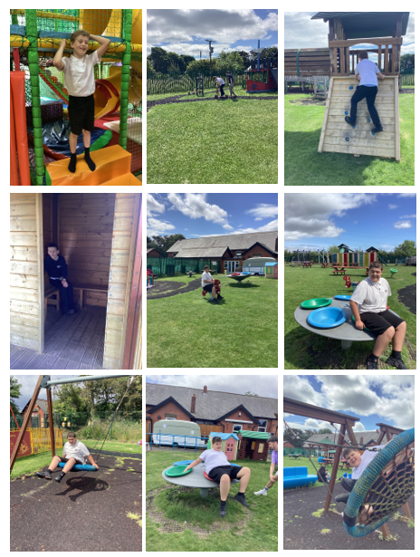
13/06/25
A1 have worked super hard this week!
This week pupils have started a new story called ‘Whatever Next’. Pupils have been getting to know the characters as well as describing them. Pupils have taken part in the sensory story to coincide with the story with items to mimic Baby Bears adventure!
In Math’s pupils have been exploring on, in and under. Pupils have worked hard identifying if characters in pictures are on, in or under a object.
In food tech we have practiced our cutting and spreading skills by making ham sandwiches, pupils then had them during snack time.
In health and well-being, we have been talking about personal space appropriateness and how our bodies belong to us!
Community Skills the pupils enjoyed walking to our local shop to explore the isles and buy an item of their choice, everyone enjoyed having their item for snack time. Some pupils have been working out how much change they will need in return and asking for receipts.
06/06/25
A1 have worked super hard this week!
This week pupils have completed a book review from our sensory story Handa’s surprise. The Children chose their favorite characters and explained which fruits they liked or disliked the smell and taste of.
In Maths pupils have been exploring capacity using different materials such as sand, rice and water to make a cup/ container full and empty! Some pupils looked at nearly full and nearly empty and measuring in millimeters. Some pupils were able to demonstrate volume of the jug from the numbers on the page and draw the correct amount on the jugs.
In food tech we have enjoyed making ham sandwiches had them during snack time.
In independent living we have been learning about road safety and identifying safe and unsafe situations.
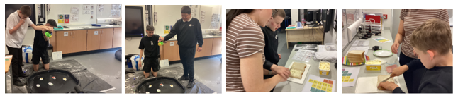
Community Skills the pupils enjoyed walking to our local shop to explore the isles and buy an item of their choice, everyone enjoyed having their item for snack time. Some pupils have been working out how much change they will need in return and asking for receipts independently.

23/05/25
A1 have worked super hard this week!
This week pupils have continued to explore our sensory story Handa’s surprise and describe the characters! Everyone is enjoying the story so far!
In Maths pupils have been exploring capacity using different materials such as sand, rice and water to make a cup/ container full and empty! Some pupils looked at nearly full and nearly empty and measuring in millimeters.
In food tech we have enjoyed making pizzas with cheese, ham and mushrooms!
In independent living we have been learning how to hoover up mess and how to be safe plugging electrics in, we have also enjoyed the sensory room, iMuse and soft play!
Community Skills the pupils enjoyed walking to our local shop to explore the isles and buy an item of their choice, everyone enjoyed having their item for snack time.
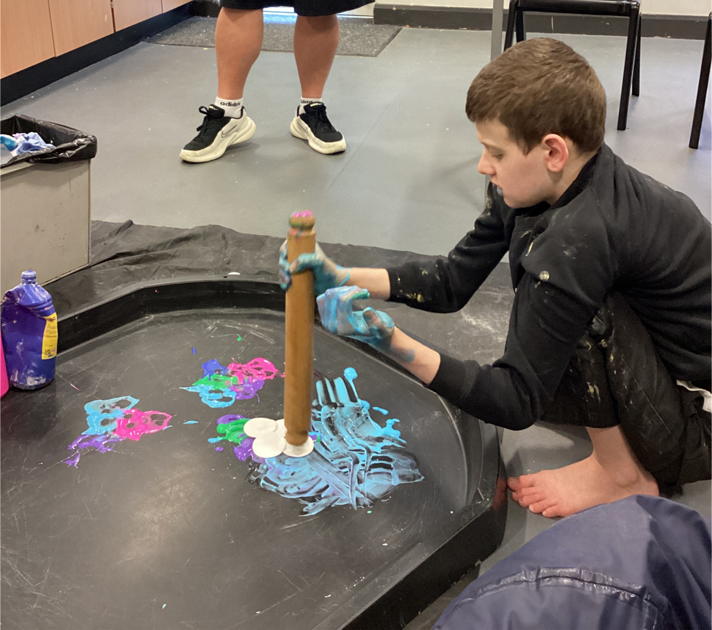
16/05/25
A1 have had a busy week! A1 have continued with their Sensory story – Handa’s surprise, the pupils have been exploring smells and tasting some of the fruits from the story. Using colour semantics to complete sentences and describe the animals and fruit.
In Maths A1 pupils have used different activities including sand, rice and buckets to explore capacity, they have been filling the bucket, emptying it and some pupils have looked at a bucket half full.
Food Tech our pupils have chopped up vegetables to make a vegetable soup, all students enjoyed taste testing the veg as part of well-being to find out whether we liked or disliked the veg and used a handheld blender to blend into soup.
Everyone enjoyed attention Autism this week and created some wonderful artwork which has been displayed outside of the classroom. Pupils used fine motor skills to follow the lines with a pen then added paint and glitter.
A1 planted some seeds in understanding the world this week
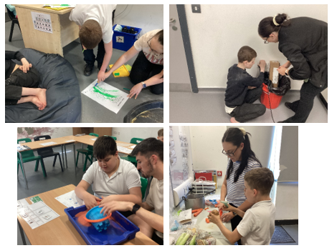
A1 have enjoyed our time in the sensory room, soft play and IMuse this week.

09/05/25
A1 have worked super hard this week!
This week pupils have explored our sensory story Handa’s surprise and completed some colourful semantics work to describe some characters and the setting! Everyone is enjoying the story so far!
In Maths pupils have been exploring heavy and light objects! Using scales to weigh objects around the classroom and using moonrocks, playdough and cubes to balance the scales.
In food tech we have enjoyed making fruit salads using our cutting skills to prepare bananas, strawberries, apples and grapes!
In independent living we have been learning how to wash dishes, we have also enjoyed our sensory room, iMuse and soft playroom!
In Community Skills, the pupils enjoyed walking to our local shop to explore the isles and buy an item of their choice, everyone enjoyed having their item for snack time.
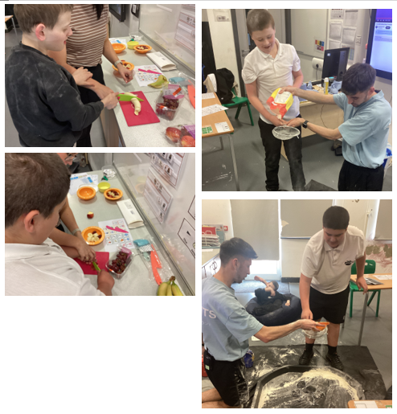

02/05/25
A1 have had a lovely first week back!
We have enjoyed our new sensory Story – Handa’s surprise and have completed work on identifying the characters and describing them.
In Math’s we have been looking at Mass and identifying heavy and light and using the scales to identify this.
In food technology we made fruit kebabs and practiced our knife skills to cut up the fruit!
In well – being we did some fruit tasting and identified whether we liked the fruit or not.
In understanding the world we looked at what food grows underground.
In independent living we sequenced the steps to wash our hands and then put it into practice!
We also enjoyed our first trip to the shops on community skills!
We have enjoyed our iMuse, sensory room and rebound sessions too!
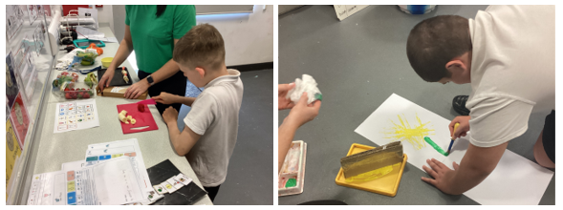
11/04/25
A1 have had an amazing half term, all pupils have worked super hard this term!
This week pupils have continued the sensory story and completed some colourful semantics work and then a book review! Everyone loved the book! We have also enjoyed our Easter sensory story ‘We are going on a egg hunt’. The pupils enjoyed exploring the sticky honey!
In Maths pupils continued to look at measurement and have started to independently use a ruler to measure!
In food tech we have enjoyed making chocolate Easter nests! We have enjoyed our attention autism sessions making shaving foam Easter chicks and Easter egg art!
In independent living we have been looking at some basic first aid and what we might do if we get hurt.
We have also enjoyed our sensory room, iMuse and soft play room!

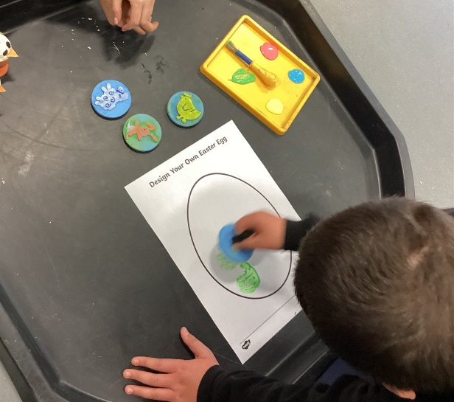
Have a lovely Easter!

04/04/25
This week in A1 we have enjoyed our sensory story Mr Wolf’s pancakes and identified who is in our story and described them and then we have described Mr Wolf in the story. In Maths we have started a new topic on measurement and have been using rulers to measure different objects in the classroom. In foo technology we have enjoyed making Easter cheesecakes. Pupils used the scales to measure out the ingredients and some pupils used an electric whisk to whisk the cream. We have enjoyed continuing with sensory poetry ‘I hear thunder’. We have enjoyed our Attention Autism with a focus of Autism acceptance month. In independent living we have continued to look athow we can look after ourselves and this week we have looked at what we can do before bed to get a good nights sleep. We have enjoyed completing some Easter crafts too. Pupils have also enjoyed going to their swimming sessions, the sensory room and iMuse.
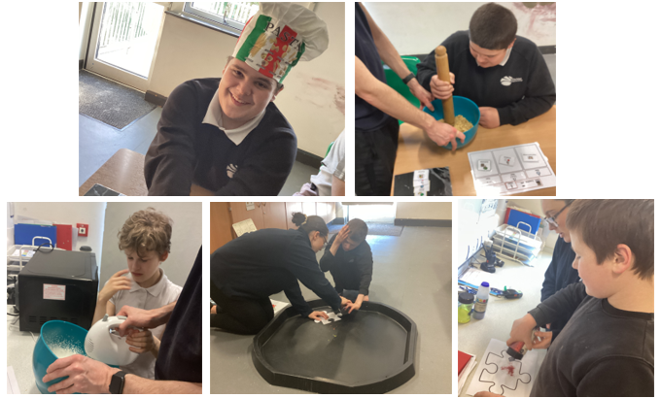
28/03/25
A1 have had a great week!
They have enjoyed their new sensory story Mr Wolf’s pancakes! The pupils have enjoyed the different props in the story and enjoyed smelling the cinnamon! Pupils have worked well on describing some settings in the story and colorful semantics. In Maths pupils have enjoyed their new topic on measurement have been ordering shortest to tallest. Pupils have enjoyed their weekly poetry this week was Five speckled frogs!
In food technology the pupils have enjoyed making naan bread! In understanding the world pupils learned about the festival of Diwali and made a lantern. In Independent living pupils learned about what they should wear in certain seasons and weathers.
Pupils have enjoyed going to the sensory room, soft playroom, iMuse and the movement room. Some pupils have enjoyed swimming too!
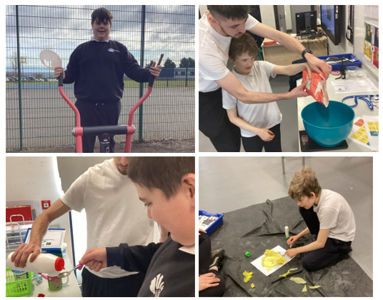

21/03/25
A1 have been really busy this week! The pupils have enjoyed the last week of the sensory story The Very Busy spider. Pupils have made a book review to say what they thought of the book and what their favourite part was! In Math we have continued to learn about money and some of us role played shops! We have enjoyed working Miss Angus in creativity.
This week we have been learning about St Patrick’s day, how people celebrate it and why we celebrate it, pupils made their own shamrock. We have also learned about Red Nose Day and why Red Nose Day happens. Pupils enjoyed our Attention autism session on Red Nose Day, and the pupils made their own red nose! Pupils also made Red Nose Day biscuits,
In Independent living we have been learning about looking after ourselves and have looked at how we need to eat healthy to look after ourselves and we also made pizzas in food technology.
In Well-being we have been looking at kind choices and what we can do each day as a random act of kindness.
We have also enjoyed our poetry lesson this week on the five little ducks.
Our pupils have enjoyed their swimming lessons, sensory room and iMuse sessions.
Some of our pupils also enjoyed a sound bath.
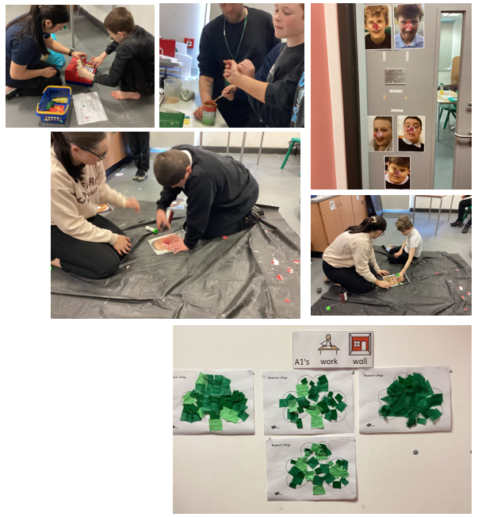
14/03/25
A1 have been really busy this week! W have continued to learn about Hinduism. Pupils have learned about the festival of Holi and we looked at the story of Rama and Sita. We have made rainbow hearts to celebrate the festival of Holi and we designed our own Tshirts of what we would wear if we celebrated the festival. We also explored different Hinduism resources and listened to some music.
In Maths we have continued to learn about money, identify coins and count in 1p, 2p and 5ps.
In English we have continued with our sensory story The Very Busy Spider and we have described characters, looked at the front cover and answered some questions about the story. The pupils have continued to work on their phonics.
In Independent living pupils have been completing household jobs such as sweeping the floor and washing hair.
In attention autism this week we have focused on science week and did some experiments such as the rainbow skittles and making a rocket and looking at what happens when bicarbonate soda is mixed with vinegar! Pupils have enjoyed our new sensory room and soft play room!
In food technology we made chicken nuggets and chips using the air fryer and learning how to use it safely.
Some of our pupils also enjoyed going to a sound bath!
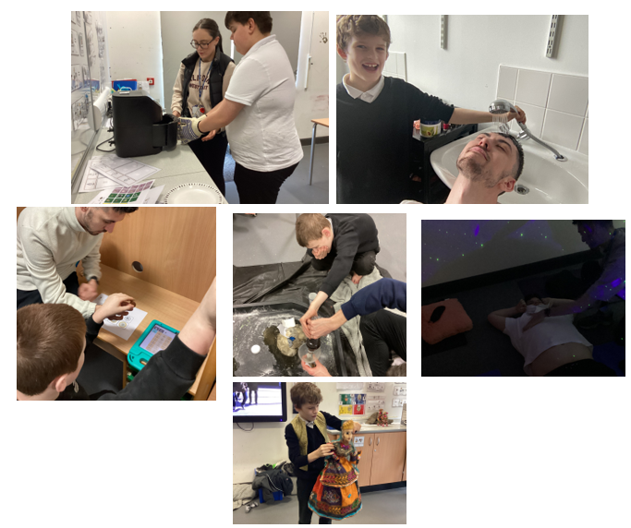07/03/25
A1 have had a busy week! This week has been the start of our new topic, Hinduism. Pupils have been taking part in attention autism sessions about Diwali. During our sessions with Miss Angus pupils learned about the Hindu religion and where they worship. Pupils painted their own temples!
This week the focus has been careers, we have focused on careers such as being a gardener and a hairdresser. Pupils have had fun using items in the tuft tray to resemble them careers.
In Math’s this week we have started to learn about money, pupils have been identifying different coins as well as counting them.
In English we have started our new sensory story, The Very Busy Spider, pupils have been working on their targets and interacting with items that resemble the story.
On Thursday 2 of our pupils have had their first hydrotherapy session of the term they had an amazing time and are looking forward to the next.
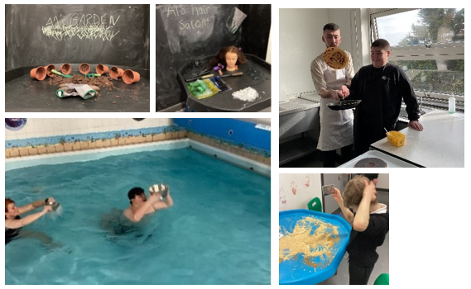
21/02/25
A1 have had a great half term! They have all worked super hard! A1 have enjoyed two sensory stories – the Monkey puzzle and Shark in the Park. Pupils have described characters, made sentences with colourful semantics and made a book review. In Math’s pupils have learned about shapes, symmetry and patterns. In Food technology pupils have focused on the skill peeling and have made chips, fruit and an orange garland. In independence we have looked at various crossing such as toucan, zebra and pelican. Students have also practiced crossing at roads as well. In understanding the world we have focused on habitats and what animals live there.
This week A1 pupils have worked well in English with their Sensory story and working on colourful semantics and even completed a book review! In Math’s the pupils have worked on patterns and even made their own with cubes! Pupils enjoyed their attention autism on feelings and made their own colour monster! In food technology pupils enjoyed making cakes and icing them!
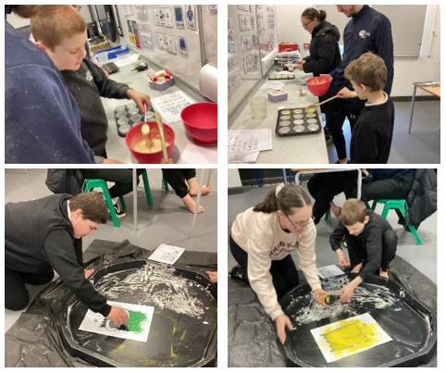

14/02/25
A1 have had a busy week this week!
We continued with our sensory story – ‘Shark in the Park’ Pupils have been working towards their targets when listening to the story. Pupils have been sequencing the story from memory. In Math’s we have been learning about symmetry and pupils have been identifying the symmetry in images by matching the other symmetrical side. In understanding the world, we have been looking at habitats and what animals are in different habitats
In Food technology we made valentine’s day cookies, pupils used heart shaped cutters to create heart cookies! We have enjoyed our Attention Autism sessions they have been valentine’s day themed, pupils have enjoyed watching hearts being made of glitter as well as blowing bubble paint to create patterns on heart shaped paper.
Have a fantastic weekend! See you on Monday for another action-packed week!
07/02/25
A1 have had a busy week this week!
We started our new sensory story – ‘Shark in the Park’ Pupils have enjoyed some sensory items such as characters from the story, grass from the park and feathers to resemble the crow. We have then described pictures from the story! In Math’s we have continued to focus on big and small, some pupils have arranged real life objects into ‘big’ and ‘small!
In Food technology we have focused on our peeling, we peeled potatoes and made them into chips using the air fryer! We have enjoyed our Attention Autism sessions in them theme of under the sea! Pupils enjoyed watching paint jelly fish form in a bottle as well as creating their own under the sea picture using a spray bottle. Pupils have also been practicing their road safety skills and identifying different types of crossings such as zebra, pelican and toucan!
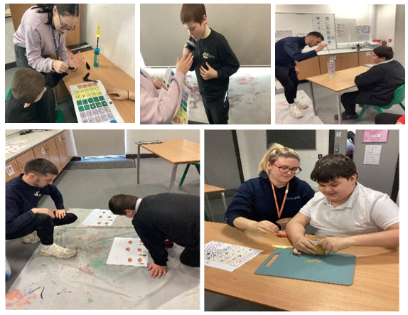
Have a fantastic weekend! See you on Monday for another action-packed week!

31/01/25
This week in A1 students have enjoyed the Chinese New Year sensory story called ‘It’s Lunar New Year’! Students enjoyed trying a taste of prawn crackers and enjoyed different sensory items in the story. Students worked well using the communication board to identify what they could see. In Math’s this week students have been learning about big and small and have been sorting objects into these two categories.
In food technology this week we have been continuing to work on peeling. Students practiced peeling an orange and then they cut up the orange into slices so that we could make an orange garment!
In wellbeing we have been continuing to play games and work on turn taking with staff and our friends!
In independent living we have been continuing to learn about road safety and sequencing the steps of crossing the road. Some students went outside to use the zebra crossing!
We have enjoyed our attention autism sessions where this week we made a big dragon for Chinese new year!
Some students have enjoyed their swimming session too.
With Miss Angus we have been learning about Georgian times and we made our very own fans! We enjoyed listening to music and playing on the keyboard.
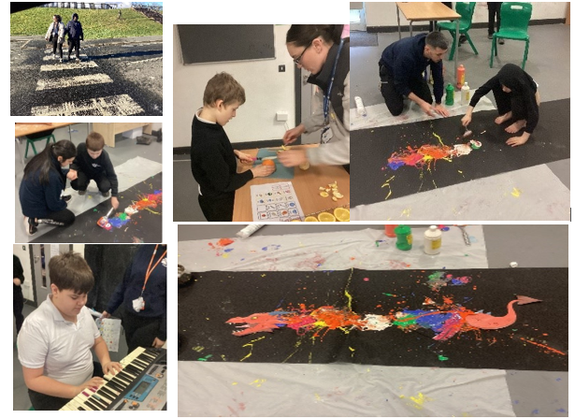

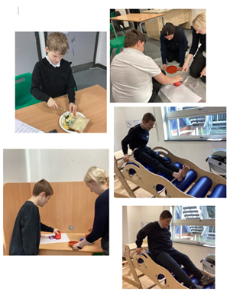
17/01/25
A1 have had a busy week this week!
We have continued to enjoy our sensory story – The Monkey Puzzle! Pupils have enjoyed some sensory frog spawn and the different animals in the story! We have then described the characters in the story! In Maths we have continued to enjoy our topic shapes, we have completed some shape printing with 3D shapes!
In Food technology we have focused on our skill peeling, we made some banana on toast! We have enjoyed our Attention Autism sessions and enjoyed the musical toys and some butterfly printing! In topic we have been learning about leadership and about our leaders in school and who helps us outside of school. We have enjoyed going to the movement room, sensory and iMuse.
We have enjoyed some sensory play.

10/01/25

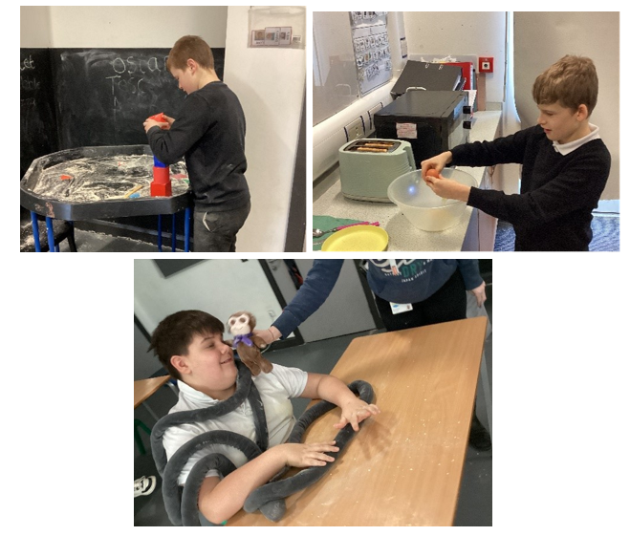
A1 have had a lovely first week back at school! We have talked about what presents we got for Christmas and what we did in the holidays! We have started our new sensory story ‘Monkey puzzle’ and have enjoyed the different animals in the story. We have enjoyed learning about 2D and 3D shapes, we have enjoyed finding different shapes in flour and drawing them in shaving foam. We have made scrambled egg on toast in food technology and have enjoyed sensory play. We have also enjoyed our Attention Autism sessions and making a mess with paint! We have enjoyed or sensory and iMuse sessions and some pupils have enjoyed their first session back at swimming!

13/12/24
A1 class have had a busy week!
This week A1 have enjoyed the sensory story for English and then completing colourful semantics to build their sentences. A1 have worked well in Maths on shape looking at 2D and 3D shapes. A1 have enjoyed some Christmas sensory play and Christmas crafts and working on our communication. In Food Technology A1 have enjoyed making snowman crispy cakes! In Independent skills we have been matching socks and some pupils have enjoyed going swimming. A1 have enjoyed their Attention Autism sessions and their time in the sensory room and iMuse.

Class certificate – OO – for having a regulated week and engaging in all his work tasks!
Maths –ML – for identifying 2D and 3D shapes!
English –JB – for engaging well in the sensory story and using colourful semantics to build sentences!

